AI-DRIVEN GENDER-BASED VIOLENCE REPORTING AND COUNSELING SYSTEM: A CASE STUDY OF JKUAT UNIVERSITY AND THE JUJA SUB-COUNTY NATIONAL POLICE SERVICE

Stephanie Wangari Katego- SCT222-0549/2022
A proposal submitted to the Department of Information Technology in the School of Computing and Information Technology in partial fulfillment of the requirement for the award of the degree of Bachelor of Science in Business Computing at Jomo Kenyatta University of Agriculture and Technology.

Year: 2026

DECLARATION
This research project is my original work and has not been presented for a degree in any other University
Signature: _______________________ Date: _______________________
This research project has been submitted for examination with my approval as University Supervisor.
Signature: _______________________ Date: _______________________

ABSTRACT
Gender-Based Violence (GBV) remains a widespread violation of human rights that disproportionately affects higher learning institutions due to various challenges such as the lack of confidential reporting channels, stigma, fear of retaliation, a lack of immediate psychosocial support and the bureaucratic inefficiencies of traditional reporting pathways. This research proposes the development of an AI-Driven GBV Reporting and Counseling System which leverages a multimodal AI model for automated detection of violence, asynchronous real-time alerts and NLP powered counseling module. This bypasses delays to simultaneously notify campus security, police dispatch and GBV administrators. The study adopts a hybrid Agile-Scrum methodology, combining the high accountability levels and safety-critical cycles of Scrum to cater for the high stakes of the SOS trigger functionality ensuring this life-saving feature works flawlessly before layering on complex features like AI-driven counseling. The expected outcome of this project is to provide a user-friendly platform that facilitates anonymous reporting, real-time alerting, psychological support and data analytics to assist campus authorities in timely intervention. Additionally, to increase the operational efficiency of the police, foster a safer campus environment, improve justice delivery and provide a technological blueprint for integrating AI into the national response to Gender-Based Violence in Kenya.

ACRONYMS
AI: Artificial Intelligence.
GBV: Gender-Based Violence.
JKUAT: Jomo Kenyatta University of Agriculture and Technology.
NLP: Natural Language Processing.
NPS: National Police Service (specifically referring to the Juja Sub-County branch).
SOS: A distress signal/trigger for emergency assistance.
TAM: Technology Acceptance Model.
RBAC: Role-Based Access Control
GWO: Gender Welfare Office

DEFINITION OF TERMS
AI (Artificial Intelligence): The foundation for the GBV alert system used to automate violence detection, provide psychological support, and enhance security through an integrated ecosystem.
NLP (Natural Language Processing): A component of AI used to provide 24/7 trauma-informed psychological first aid, forensic entity extraction from survivor narratives, and automated counseling modules.
Serverless: An architectural approach using functions and event-driven backends to ensure emergency alerts are processed without the need to manage physical computers or maintain constant server uptime.
Cloud: Secure, scalable remote infrastructure used for hosting AI APIs, storing immutable evidence and ensuring system availability during high-traffic periods.
Synchronous: Traditional communication models that are human-dependent and request-response based, often introducing delays during emergencies.
Agile Methodology: An iterative development approach that allows for continuous refinement of system modules and the ability to pivot based on evolving legal standards or stakeholder feedback.
Scrum Methodology: A specific Agile framework that uses time-boxed sprints to ensure high-stakes features like the SOS trigger are developed and validated with high accountability.
Psychological Support: The provision of immediate, trauma-informed psychological first aid and risk assessments via AI to reduce the risk of trauma-induced conditions like depression.
Latency: The delay in system response.
Asynchronous Architecture: A system design where event processing happens in parallel to multiple responders without causing system bottlenecks.

Evidence Decay: The loss or alteration of critical forensic details that occurs during the delay between an incident and its official documentation.

Geospatial Analytics: The use of GPS and location data to identify violence hotspots and inform targeted security interventions.

Immutable Cloud Storage: Data storage (often referred to as WORM - Write Once Read Many) that prevents administrators from deleting submitted evidence to ensure legal integrity.

Stigma Friction: The psychological and physical resistance survivors face when reporting due to fear of judgment, victim-blaming, or the cumbersome nature of manual processes.

Table of Contents
DECLARATION 2
ABSTRACT 3
ACRONYMS 4
DEFINITION OF TERMS 5
LIST OF TABLES 9
LIST OF FIGURES 10
CHAPTER ONE: INTRODUCTION 11
1.1 Background 11
1.2 Project Overview 12
1.3 Statement of the Problem 13
1.4 Proposed Solution 15
1.5 Objectives 16
1.6 Research Questions 16
1.7 Justification 17
1.8 Proposed System Methodologies 18
1.8.1 Research Methodology 18
1.8.2 System Implementation Methodology 19
1.9 Scope 21
CHAPTER 2: LITERATURE REVIEW 22
2.1 Introduction 22
2.2 Theoretical Review 23
2.3 Case Study Review 30
2.4 Integration and Architecture 36
2.5 Summary 38
2.6 Research Gaps 39
CHAPTER 3: SYSTEM ANALYSIS AND DESIGN 41
3.1 Introduction 41
3.2 SYSTEM DEVELOPMENT METHODOLGY 42
3.3 FEASIBILITY STUDY 44
3.3.1 Technical Feasibility 44
3.3.2 Economic Feasibility 45
3.3.3 Operational Feasibility 48
3.3.4 Legal and Ethical Feasibility 49
3.4 REQUIREMENT ELICITATION 49
3.4.1 Data Collection 49
3.5 DATA ANALYSIS 52
3.5.1 Student Survey Analysis 52
3.5.2 GBV Office, Campus Security and Juja NPS Analysis 57
3.5.3 System Requirements Analysis 58
3.6 SYSTEM SPECIFICATION 58
3.6.1 Functional Requirements 58
3.6.2 Non-Functional Requirements 60
3.7 REQUIREMENT ANALYSIS AND MODELING 62
3.7.1 Use Case Diagram 62
3.7.2 Data Flow Diagram (DFD) – Level 0 (Context Diagram) 63
3.8 LOGICAL DESIGN 64
3.8.1 System Architecture 64
3.8.2 Control Flow and Process Design 65
3.8.3 Design for Non-Functional Requirements 69
3.9 PHYSICAL DESIGN 72
3.9.1 Database Design 72
3.9.2 User Interface Design 75
REFERENCES 81
APPENDICES 83
Appendix A: Project Resources 83
Appendix B: Proposed Budget 84
Appendix C: Project Timeline 85
Appendix D: Gantt Chat 87

LIST OF TABLES
Table 1: Case Study Comparison of Crowd Sourcing Apps 28
Table 2: Case Study Comparison of Emergency Assistance Apps 30
Table 3: Case Study Comparison of Self-learning Apps 32
Table 4: Project Budget 42

LIST OF FIGURES
Figure 1: Student Awareness of JKUAT's Gender Welfare Office 53
Figure 2: Students’ belief in current reporting systems in JKUAT University 53
Figure 3: Barriers to GBV Reporting Among JKUAT Students 54
Figure 4: Anonymity preference among JKUAT Students 55
Figure 5: Key Features That Would Increase JKUAT Students' Confidence in Using a Digital GBV Reporting Tool 56
Figure 6: Students’ willingness to use an AI-powered chat bot for emotional support 56
Figure 7: Use Case Diagram Illustrating Interactions Between Survivors, GWO, Juja NPS and Campus Security. 62
Figure 8: Data Flow Diagram Illustrating Relationships Between Internal and External Entities of the System. 63
Figure 9: Project Gantt Chat showing the project timeline 87

CHAPTER ONE: INTRODUCTION

1.1 Background
Gender-Based Violence (GBV) affects individuals across all demographics, particularly women and marginalized groups. On university campuses, GBV can manifest as sexual harassment, coercion, assault and other forms of abuse, negatively impacting victims’ well-being, safety and academic performance. Despite awareness campaigns and policy interventions, the rate of GBV reporting remains disproportionately low. Approximately 50% of young women in Kenyan universities have experienced violence, yet only 15.7% report these incidents to authorities (Wangu Kanja Foundation and Amref International University, 2024). This research investigates the application of Artificial Intelligence (AI) to enhance security and public trust in GBV reporting while remaining adaptable to varying infrastructure capabilities.
Electoral-style reporting processes for sensitive incidents like GBV face persistent challenges that undermine institutional integrity and survivor safety (Supreme Court of Kenya, 2022). Higher education institutions have increasingly come under scrutiny for their responses to GBV. leading to the global deployment of technological solutions to promote safe reporting and data tracking (UN Women, 2022). Notable examples include mobile applications in India and South Africa such as Safetipin and Namola which facilitate emergency alerts, real-time location tracking, and anonymous reporting (International Telecommunication Union [ITU], 2023)
In Kenya, GBV cases within universities are often underreported. Cultural stigmas, victim-blaming, fear of reprisal, and ineffective institutional mechanisms are major contributors to the silence. While some universities have policies in place, there remains a glaring gap in the integration of ICT tools that can help in detecting and reporting such cases. This study addresses this gap by proposing an information system designed for university environments in Kenya.

1.2 Project Overview
This research investigates the application of Artificial Intelligence (AI) to enhance security and public trust in Gender-Based Violence (GBV) reporting and counseling, specifically focusing on higher learning institutions like Jomo Kenyatta University of Agriculture and Technology (JKUAT). The study examines how a multi-tiered emergency response engine can transform a single distress signal into a coordinated rescue and recovery operation while remaining adaptable to varying infrastructure capabilities.
From a global perspective, the (World Health Organization, 2021) identifies Gender-Based Violence (GBV) as a global health problem of epidemic proportions, affecting nearly one in three women worldwide. Increasingly, technology-facilitated GBV is on the rise, necessitating a shift toward Safety-by-Design principles where mobile technologies are utilized to bypass traditional institutional gatekeepers (UN Women, 2022).
Locally, the Kenyan scenario is marked by a significant reporting gap within higher learning institutions. Despite the presence of robust administrative structures at Jomo Kenyatta University of Agriculture and Technology (JKUAT), a pervasive silence culture persists, largely driven by the physical and psychological friction associated with manual, paper-based reporting (Wangu Kanja Foundation & Amref International University, 2024).
The project will analyze key computational principles such as:
- AI and Natural Language Processing (NLP): Use of NLP to provide trauma-informed, 24/7 psychological first aid and employing it for forensic entity extraction which identifies markers in a survivor's narrative to automate legal documentation.
- Asynchronous Architecture Analysis: Evaluation of serverless functions and event-driven backends to ensure that emergency alerts are processed in parallel to multiple responders without system bottlenecks.
- Real-Time Integration Methodologies: Development of low-latency synchronization using WebSockets and SMS gateways like Twilio to connect survivors with JKUAT Security and the Juja National Police Service simultaneously while providing low-latency synchronization of GPS data between the student and the police dashboard.

1.3 Statement of the Problem
Despite various institutional policy efforts and awareness programs, GBV remains underreported in Kenyan universities by a staggering 1:3 ratio where for every reported case, three remain untold (Wangu Kanja Foundation & Amref International University, 2024). The core research problem lies in the technological and systemic failure of current reporting mechanisms, which are built on centralized, manual, or hybrid-digital architectures that lack the necessary integrity and immediacy to handle sensitive forensic data.
The gravity of this problem is evidenced by recent national data that reported 579 femicide cases in 2024 and an additional 129 cases in the first quarter of 2025, indicating a lethal trend where an average of one woman is killed daily (The Kenya National Police Service, 2025). Within the university context, 50% of young women have experienced violence, yet only 15.7% report these incidents to authorities. This discrepancy is largely due to evidence decay and stigma friction especially with men whereby only 14.4% of their cases are reported (Wangu Kanja Foundation & Amref International University, 2024)
The current system's inadequacies are manifested through several critical dimensions:
- The "Silent Victim" Dilemma: Traditional emergency calls are unsuitable for active GBV threats where speaking aloud may escalate danger. Furthermore, the 5% conviction rate in Nairobi County where only 1,200 out of 24,000 cases reach a verdict is directly attributed to poor documentation and delayed reporting (Kenya Demographic and Health Survey [KDHS], 2022).
- Centralization Risks: Existing protocols lack synchronized awareness. Often, the National Police Service (NPS) is contacted while JKUAT security remains unaware or vice versa, creating a response vacuum. In a crisis, the seconds lost manually dialing numbers or describing vague locations in large complexes can lead to fatal outcomes.
- Delayed Response Times: In a crisis, manually dialing a number or typing a message takes too long. Every second lost increases the risk of harm. The critical nature of this in emergency response and the failure of manual dialing is a staple of emergency medical and security research (National Police Service, 2023).
- Neglected Aftercare: Most systems focus only on the 5 minutes of the emergency. The "6th minute", counseling, legal steps and administrative logging is usually disorganized or forgotten. The gap between physical safety and psychological/legal recovery is a major theme in trauma-informed care studies (Ministry of Health, 2020).
- Security and Integrity Vulnerabilities: Manual records are susceptible to manipulation and unauthorized access. Centralized databases at local stations represent a single point of failure, with Kenyan officials noting over 200 attempted breaches of governance systems in 2022 (National Cybersecurity Strategy for 2022–2027, Republic of Kenya, 2022).
- Lack of Precise Location: Traditional emergency calls often provide vague locations. In a large school or complex. The failure of traditional GPS/Cell-tower triangulation in high-density campus environments is a recognized technical gap in geospatial security (International Telecommunication Union, 2024).
Therefore, the research problem is the absence of a decentralized, AI-driven and real-time emergency response engine capable of automating the Safety-to-Justice pipeline. Without an integrated system that combines silent triggers, automated P3 triage and immutable evidence storage (World Health Organization, 2021) , GBV survivors at JKUAT will continue to face barriers of fear and stigma, while perpetrators benefit from the systemic documentation failures of the current administrative infrastructure.

1.4 Proposed Solution
This research seeks to apply Artificial Intelligence as a foundation for Gender-Based Violence alert systems that address the identified challenges and aim to report and offer psychological support for GBV incidents on university campuses. The application will allow students to report incidents anonymously while enabling the police service and campus administrators to track, analyze and respond to trends in real-time. The solution will incorporate the following key system operations:
- Anonymous reporting options
- Unified instant trigger for real-time alerts in emergencies
- Multi-tiered architecture for synchronized alerting
- A case management dashboard
- Secure data storage and access control
- Integration of links to legal and psychosocial support services
- High accuracy geospatial tracking and;
- Aftercare support.
The technological improvement of this research lies in its shift from synchronous, human-dependent models to an integrated, asynchronous AI-automated ecosystem. By transitioning from a traditional request-response architecture to an event-driven detection framework, the system treats a distress signal as an immediate event that triggers the entire backend. This ensures that alerts reach JKUAT Security and the Juja National Police Service in milliseconds, eliminating the server bottlenecks common in legacy systems.
Finally, the research enhances support accessibility by moving beyond limited human-led waitlists to 24/7 automated trauma-informed counseling by fine-tuning NLP with specific psychological guardrails, the system provides immediate, specialized psychological first aid and risk assessments at the moment of detection, ensuring that survivors are never left without guidance during the critical minute of an incident.

1.5 Objectives

General Objective:
To design and develop an AI-driven Gender-Based Violence alert system for reporting and counseling of Gender-Based Violence (GBV) cases to enhance emergency response and case management for JKUAT Gender Welfare Office and the university students.

Specific Objectives:
  - To investigate critical gaps and key incident and psychological data elements for reporting and counseling through existing GBV reporting systems and computing technologies.
  - To implement the core incident attributes and psychological variables required for effective reporting of incidents and provision of psychological support.
  - To develop an asynchronous, event-driven backend to ensure real-time alerts and a multimodal AI module for psychological first aid to survivors.
  - To validate the system’s performance to ensure it meets confidentiality, security and notification latency requirements.

1.6 Research Questions
- What are the systemic gaps in current GBV reporting systems that contribute to high stigma friction and evidence decay?
- What are the critical incident metadata and psychosocial data elements required to provide effective trauma-informed psychological help?
- What architectural requirements are required to ensure zero-latency alert synchronization and effective trauma-informed support?
- What best practices should be followed to integrate a system that meets the strict confidentiality and security standards required?

1.7 Justification
This study addresses a critical gap between policy and practical tools for GBV intervention in academic spaces. Developing a tailored GBV information system will provide a structured platform for safe disclosure, support seeking, and institutional response, contributing to safer campuses and informed policy development. There is a critical need to bridge the reporting gap that currently leaves university men and women vulnerable to Gender-Based Violence (GBV).
Current reporting methods at Jomo Kenyatta University of Agriculture and Technology (JKUAT) rely on manual, face-to-face interactions at security desks or police stations. This manual processing creates stigma friction, where survivors fear judgment or victim-blaming. Furthermore, the delay between an incident and its documentation leads to evidence decay, where critical forensic details are lost or altered before a P3 form can be issued. This research is necessary to transform reporting from a reactive, intimidating hurdle into a proactive, survivor-centric digital safety net.
This study contributes to the field of computational law and forensic AI by moving beyond simple emergency apps to an integrated multimodal AI framework. It addresses the human induced delay in security dispatch by implementing an asynchronous, event-driven architecture that bypasses traditional, slow communication channels.
Benefit to the Clients
- The Student Body: Survivors gain an anonymous, judgment-free gateway to assistance. The NLP counseling provides immediate psychological first aid, reducing the risk of trauma-induced depression or academic withdrawal.
- National Police Service (Juja NPS): Officers receive high-fidelity, NLP-transcribed reports that are pre-populated with forensic markers. This reduces administrative burnout and provides the evidence required to improve the current 5% conviction rate for university GBV cases (Kenya Demographic and Health Survey [KDHS] 2022).
- University Administration: JKUAT gains a real-time dashboard allowing security to deploy patrols to high-risk zones based on geospatial SOS triggers.

1.8 Proposed System Methodologies

1.8.1 Research Methodology
A mixed-method approach will be used. Quantitative data will be collected via structured surveys such as Google Forms from students to ensure anonymity which is critical for GBV research. Links will be shared via university email lists or school WhatsApp groups. Stratified Random Sampling will be applied whereby the student population will be divided into strata, for example, by gender or year of study to ensure the data represents the diverse demographics of JKUAT University.
Qualitative data will be gathered through interviewing the Gender Welfare Office, campus security and counselors in JKUAT University as well as the Juja Police. For the case studies, Documentary Analysis will be used to analyze documented reports of incidents locally and globally.
The research will be conducted in these phases:
- Problem Definition and Requirement Engineering Phase: This phase identifies the challenges faced by GBV victims as they report their cases and seek mental support. It will establish the baseline for the system functional and non-functional requirements. It will also focus on stakeholder engagement and ensure user needs remain central to technical considerations.
- Literature Review: A comprehensive review of existing literature on Gender-Based Violence reporting mechanisms and AI application in counseling systems. This will inform the choice of reporting, counseling techniques, system architecture and evaluation metrics.
- System Design Phase: This stage involves designing a serverless architecture to handle the alerts to multiple responders simultaneously without server bottlenecks as well as selecting the AI engines needed for counseling while designing a database to store unstructured incident narratives and transcripts.
- Iterative Development (Sprints) Phase: Implementation will follow an incremental approach to allow for modular testing of the AI. Additionally, it will involve building the user interface and the dashboard for the campus security and school administration. It will also involve coding the pipeline that receives the SOS alert and transcriptions. Lastly, it will involve engineering the system prompt for the counseling bot using the Kenyan Sexual Offences Act and JKUAT Student Policies as the knowledge base to ensure legal and emotional accuracy.
- Verification & Validation Phase: This phase will involve automated tests to verify that the SOS Button trigger successfully invokes the cloud. Through a focus group of student volunteers, the NLP counseling module will be evaluated to review empathy scores and the clarity of the legal guidance provided successfully function. It will also undertake measuring system performance under simulated high-load such as multiple concurrent SOS triggers to ensure zero-latency alert synchronization.
- Analysis and Documentation: Results from the evaluation phase will be analyzed to determine whether the system meets the study objectives. Findings will be documented, highlighting technical performance, practical relevance, and limitations.

1.8.2 System Implementation Methodology
The system will employ an iterative, user-centered design approach leveraging Agile development methodology, adopting Scrum methodology to accommodate specialized requirements of gender-based violence alert systems. This methodology allows for the continuous refinement of the NLP counseling modules. Scrum methodology is integrated into the development of this GBV alert and reporting system to ensure there is a structured operational framework that transforms flexibility into accountability. In the high-stakes context of a GBV emergency system, Scrum’s use of time-boxed sprints ensures that life-saving features like the SOS trigger are developed, tested and validated every two weeks, preventing the project from drifting into vague or unfinished states.
This method will facilitate:
- Stakeholder Alignment: Developing a system for both JKUAT Security and Juja Police requires frequent feedback. Agile ensures the dashboard meets the specific administrative needs of the Kenyan police without waiting for the final release and Scrum ensures collaborative feedback loop where the JKUAT GBV Office and authorities act as active stakeholders during sprint reviews.
- Flexibility with Legal Standards: As Kenyan data protection regulations evolve, the methodologies allow the research to pivot and integrate new confidentiality protocols mid-development.
- Time-to-Value: By breaking the system into manageable sprints, a functional SOS button can be tested and validated long before the NLP counseling module is fully finished, ensuring steady progress throughout the research cycle.
- Quickly fixing of bugs: Scrum allows for the immediate identification and resolution of bugs within short sprint cycles, ensuring the SOS button and alert delivery remain functional and reliable.

1.9 Scope
The scope of this research is defined by its focus on integrating AI technology into the specific security and social ecosystem of a Kenyan university. It acts as a boundary to ensure the project remains achievable.
Geographical and Demographic Focus
- Geographical Area: The study is confined to Jomo Kenyatta University of Agriculture and Technology (JKUAT) Main Campus in Juja. The SOS trigger and GPS synchronization will be optimized for the university's layout and the immediate surrounding student residential areas.
- Target Population: The users are JKUAT students, Juja National Police Service, university's internal security team and GBV Office who will interact with the administrative dashboard for incident response.
Technical and Functional Boundaries
- System Capabilities: The project will confine itself to the development of a responsive web application featuring a SOS trigger and an NLP counseling interface.
- AI Specialization: The NLP module will be specifically grounded in the Kenyan Sexual Offences Act and JKUAT’s Gender Policy.
- Data Handling: The system will focus on the initial hour of reporting and the pre-population of forensic data, it will not manage the entire life cycle of a court case or judicial archive.
Potential Limitations
- Data Availability: Due to the sensitive and confidential nature of GBV cases, the research will rely on simulated datasets and volunteer user testing rather than real-life active police case files to protect survivor privacy.
- Internet Connectivity: As a cloud-based AI system, the speed of the alert delivery is limited by the bandwidth and network stability of the local telecommunications infrastructure in Juja.

CHAPTER 2: LITERATURE REVIEW

2.1 Introduction
This literature review explores the integration of Artificial Intelligence (AI) in addressing Gender-Based Violence (GBV) within the context of Jomo Kenyatta University of Agriculture and Technology (JKUAT) focusing on reporting and counseling mechanisms within university campuses. The review explores global and regional trends, theoretical frameworks underpinning GBV reporting systems and critiques the existing literature to identify gaps that justify the current study.
Traditional reporting mechanisms such as physical offices often suffer from low engagement due to potential victim-shaming, fear of retaliation, inaccessible reporting hours or locations and fragmented workflows between security, counseling and administration. JKUAT, as a leading technological hub, presents an ideal environment for testing digital interventions. The use of technology to combat GBV has evolved from simple emergency hotlines to sophisticated web app platforms and GIS-based safety mapping. Web apps in campus settings serve as a digital front door for survivors. The purpose and objectives of this review is:
- To establish a multidisciplinary foundation for the system.
- To synthesize theories that explain why survivors choose or avoid digital reporting.
- To examine the efficacy of AI chatbots in providing trauma-informed counseling, theoretical shifts from individual-focused safety to systemic and survivor-centered frameworks.
- To identify the best practices and misses in existing campus-based reporting apps.
- To define the architectural principles required to integrate mobile alerts with administrative analytics.

2.2 Theoretical Review
Key Concepts and Variables
There are various variables relevant to my research area which include:
  - Anonymity vs. Accountability
In GBV reporting, anonymity is critical for encouraging disclosure, particularly in environments where survivors fear stigma, retaliation or disbelief. This study conceptualizes anonymity and accountability as interdependent variables, requiring a balanced system design that protects survivor identity while preserving evidentiary integrity through metadata, timestamps and secure audit trails.
  - Real-Time Latency
In emergency GBV situations, even minimal delays can significantly affect survivor safety. Within this study, real-time latency is treated as a technical performance variable influencing system effectiveness, particularly in cases requiring immediate intervention.
  - Geospatial Analytics
In the context of this study, geospatial data enables the identification of GBV hotspots within JKUAT and surrounding areas of Juja Sub-County. This concept supports evidence-based decision-making by allowing institutions to deploy targeted security interventions, improve campus infrastructure, and inform policy.
  - Survivor-Centered Design
It informs system logic by allowing survivors to control disclosure levels, choose reporting pathways, and access support without coercion. This concept aligns with feminist and ethical computing theories, positioning survivor agency as a core system variable rather than an optional feature.
  - Natural Language Processing (NLP)
The availability of 24/7 AI-based counseling positions NLP as both a support variable and an accessibility enhancer within the GBV response ecosystem. This concept supports efficient prioritization of cases, ensuring that high-risk situations receive immediate attention.
  - Cloud-Native AI Infrastructure
Cloud services are conceptualized as enablers of elastic computing, allowing the GBV reporting and counseling system to automatically scale resources in response to fluctuating user demand. This is particularly important during high-traffic periods such as weekends, university events, or emergency incidents when simultaneous reporting may occur.
Theoretical frameworks provide a foundational basis for understanding the dynamics of gender-based violence and the interventions needed for its detection and reporting. Several theories have been applied in GBV studies, and for this research, these theories are relevant:
Routine Activity Theory (RAT)
The Routine Activity Theory, as proposed by Cohen and Felson (1979), posits that for a crime to occur, three elements must converge: a motivated offender, a suitable target, and the absence of capable guardianship. In the context of university campuses, students, particularly females often become vulnerable targets due to environmental and social factors, such as secluded areas, social events, or unequal power relations. These routine activities increase exposure to potential offenders, especially in contexts where formal guardianship is weak or delayed.
The theory emphasizes that crime is not only a result of offender motivation but also of situational opportunities. Applying this theory, reporting systems serve as capable guardians by offering protective mechanisms for students through real-time reporting, alerts and incident tracking features. By enabling immediate digital escalation to JKUAT administrators and the Juja Sub-County National Police Service, the system disrupts the crime opportunity structure identified by Routine Activity Theory (Felson & Boba, 2010).
- Pros:
- It supports proactive safety interventions by shifting focus from post-incident responses to real-time intervention.
- The theory also justifies the system’s ability to support hotspot mapping and environmental crime prevention strategies on and around the university.
- Cons:
- Traditional RAT does not account for the “silent victim” dilemma, where the presence of a guardian (the phone) is useless if the victim is too afraid to use it.
- It can also lead to victim-blaming by focusing on target suitability, which this study mitigates by integrating survivor-centered and feminist frameworks.

Technology Acceptance Model (TAM)
Proposed by Davis (1989), the Technology Acceptance Model explains how users come to accept and use a technology. The model identifies two key factors: perceived usefulness and perceived ease of use. In this study, the implementation of a GBV reporting system relies on students’ acceptance of the platform, influenced by their belief in its utility to address reporting challenges and the simplicity of its interface (Venkatesh & Bala, 2008).
Given the sensitive nature of GBV reporting, students may abandon systems perceived as complex, bureaucratic, or time-consuming. This study applies TAM to guide the design of a simplified, intuitive interface such as a one-tap silent reporting trigger, guided AI counseling prompts, and automated referrals ensuring the system aligns with user expectations and emotional states (Venkatesh & Bala, 2008). The model will also inform evaluation of usability and adoption levels among JKUAT students.
- Pros: Explains why students might prefer minimal-interaction features such as a single-button silent trigger over a complex reporting form, particularly during distress.
- Cons: TAM often overlooks perceived risk where a student might find a system useful but fear that using it lacks confidentiality.
Socio-Technical Systems Theory
Socio-Technical Systems Theory argues that effective systems must integrate both technological components and the social structures in which they operate. The theory emphasizes that technology cannot function in isolation but must align with organizational workflows, institutional norms and human behavior. The theory underscores that AI decision-making must reflect real institutional processes, such as evidence handling, counseling escalation and legal reporting thresholds. Without this alignment, even advanced AI tools risk operational failure.
- Pros: Ensures institutional interoperability and sustainable adoption by embedding the system within existing governance and response structures.
- Cons: Requires extensive coordination between multiple stakeholders, increasing implementation complexity and resistance to change.
Social Exchange Theory
Social Exchange Theory posits that individuals make decisions based on a perceived cost-benefit analysis. In GBV reporting, survivors often weigh potential benefits such as justice, safety or healing against perceived costs including stigma, retaliation, emotional distress and procedural burden.
- Pros: Explains how AI reduces reporting “costs” through anonymity and non-judgmental interaction.
- Cons: The theory assumes rational decision-making and cannot fully explain trauma-induced fear or emotional paralysis, which may persist despite reduced barriers.
Objectification Theory
Objectification Theory suggests that societal tendencies to reduce individuals, particularly women, to objects contribute to internalized shame, self-blame and silence following abuse. This internalization often discourages survivors from reporting incidents or seeking help.
- Pros: AI acts as a neutral mediator, helping survivors regain agency without the judgment of a human interviewer and enables survivors to engage at their own pace.
- Cons: Automated systems may lack cultural nuance and contextual empathy, particularly in diverse Kenyan socio-cultural settings.

Three-tier Architecture Theory
Three-Tier Architecture Theory structures systems into the Interface Layer (survivor interaction), Application Logic Layer (AI reasoning and workflows) and Core Data Layer (secure storage). This separation enhances scalability, security, and maintainability.
- Pros
- Improved Security of Sensitive Data: Separating the interface, application logic, and data layers limits direct access to sensitive survivor information. This layered protection is critical for safeguarding GBV reports and maintaining confidentiality.
- High Scalability: Each layer can be scaled independently based on demand. For instance, increased reporting activity can be handled by scaling the application logic layer without affecting the user interface or data storage components.
- Ease of Maintenance and Updates: Changes made to one layer do not require modifications to the others. This makes it easier to update the mobile interface or improve AI logic without disrupting the entire system.
- Enhanced System Reliability: The modular structure improves fault tolerance. Failure in one tier does not necessarily lead to complete system downtime, ensuring continued access to reporting and counseling services.
- Support for Institutional Integration: The architecture enables seamless integration with external systems such as university administration platforms and police information systems, which is essential for coordinated GBV response.
- Cons
- Higher Development Complexity: Designing and managing three separate layers requires advanced technical skills and careful coordination, increasing development time and effort.
- Increased Infrastructure Costs; Multiple servers or services may be required to support each tier, leading to higher hosting and maintenance costs.
- Performance Latency Risks: Communication between layers can introduce delays, particularly when AI processing and database access occur simultaneously, which may affect real-time reporting.
- Dependence on Network Stability: The architecture relies on consistent network connectivity. Poor or unstable internet access can disrupt communication between layers, affecting system availability.
- Complex Debugging and Monitoring: Identifying and resolving errors across multiple tiers can be challenging, as issues may originate in one layer but appear in another.
Survivor-Centered Framework
The Survivor-Centered Framework prioritizes survivor autonomy, consent, privacy and emotional safety throughout the reporting process. The system allows survivors to control disclosure levels, choose reporting pathways and access support without coercion.
- Pros: High user trust; ensures ethical data handling and psychological safety.
- Cons: Can conflict with mandatory reporting laws or immediate police protocols in severe cases.
Technological Diffusion Framework
This framework explains how innovations spread within communities. Adoption depends on perceived relevance, simplicity and social acceptance. The system is designed to feel supportive and conversational, resembling a digital mentor rather than a rigid institutional form. The success of a system depends on how easily it is adopted by its users. It focuses on making the AI interface feel like a friend or a mentor rather than a cold institutional form.
- Pros: Helps in designing an interface that feels like a digital companion rather than a government form, encouraging voluntary adoption and sustained engagement.
- Cons: Digital literacy gaps and access inequality may limit adoption if design is not inclusive and too complex.
Systemic/Organizational Theory
Systemic Theory views GBV as a failure of institutional structures rather than individual behavior. The system enforces accountability by ensuring cases are logged, tracked and escalated across institutional actors. Views GBV as a failure of institutional structures rather than individual behavior.
- Pros: Drives multi-stakeholder workflows, administrative accountability, transparency and multi-agency coordination.
- Cons: Harder to implement technically; requires deep integration with legacy systems and dependent on institutional cooperation.

Feminist AI Framework
The Feminist AI Framework advocates for technology that actively challenges gendered power imbalances. In this study, AI language, recommendations and counseling logic are designed to avoid bias, victim-blaming, or stereotyping.
- Pros: Ensures the AI doesn't use biased language or reinforce harmful stereotypes in its counseling therefore promoting ethical, inclusive and empowering system behavior.
- Cons: Implementing algorithmic fairness is technically complex and resource-intensive.

2.3 Case Study Review
This section analyzes implemented AI-driven GBV reporting systems globally, examining their architectures, outcomes, limitations, features and current status. These real-world implementations provide critical insights into practical challenges and success factors for GBV reporting and counseling mechanisms.
Review of Different types of GBV Reporting Apps
Crowd Sourcing Apps: They attempt to tie violence to users’ space /location (geography) enabling them to report incidents of violence and then put them on a map to visualize the violence hotspots.
Self-help Learning Apps: These apps are designed to increase users’ understanding of violence and also engage in self-learning and self-assessment of their risk of abuse. They may also link users to supportive services, including lawyers, social and community workers, shelters and clinics.
Emergency Assistant Apps: When users are in an emergency situation, they can trigger an SOS alert which sends messages to their emergency contacts. Some apps also allow users to call emergency dispatch when the emergency alert is triggered.
Comparative Survey of Mobile Crowdsourcing Reporting Apps
App Name & Geography | Current Status (as of 2026) | Purpose & Key Features | Computing Technology Used | AI or Cloud Usage | Pros & Main Outcomes | Cons & Limitations
HarassMap (Egypt)  2010 | Functional | Anonymous reporting of sexual harassment in real-time. Features an interactive GIS map to identify "hot spots." | Ushahidi platform (PHP/MySQL), Google Maps API, SMS integration. | Cloud: Uses Crowdmap (cloud version of Ushahidi). AI: None. | Empowered women to report safely; Provided data for police advocacy. | Underreporting in areas with low internet; Cultural stigma; Limited data management in early years.
Women Under Siege (Ukraine/Syria/Global)  2012 | Functional | Documenting sexual violence in conflict zones. Uses mapping to track patterns of abuse. | Crowdmapping technology, Social media scrapers, Secure web database. | Cloud: Cloud-based data storage for remote access.  AI: None. | Highlights rape as a weapon of war; Supports international justice. | Highly dangerous for users; Data verification is difficult in active war zones; State-sponsored censorship.
GBV Project Apps (Cambodia)  2019-2021 | Functional (Part of NAPVAW III) | Prevention of GBV through educational messages and monitoring child sexual exploitation. | Mobile messaging systems, Social media monitoring tools. | Cloud: Integrated with govt. subnational servers.  AI: None. | Strong government backing; Integrated with local social protection; Targets rural areas. | High underreporting; Limited by rural digital divide and educational barriers.

Table 1: Case Study Comparison of Crowd Sourcing Apps

Comparative Survey of Emergency Assistance Apps
App Name & Location | Status | Purpose & Features | Computing Technology | AI/Cloud | Pros & Main Outcomes | Cons & Limitations
React Mobile, USA  2013 | Functional | Personal safety app to alert contacts and 911 with GPS location. | Smartphone app with optional "React Sidekick" wearable device. | None | Wearable device allows alerts even if the phone is out of reach. No subscription fee. | Smartphone only; indirect costs of data plans.
Pukar, India  2013 | Functional | Push-button alert to five registered contacts with SMS and location details. | Mobile app; automatically switches to silent mode and turns on GPS. | None | Police receive signal only when a contact forwards the SOS alert. | Acts only as a deterrent; cannot directly contact police.
EyeWatch, India  2013 | Functional | Sends SMS/email alerts and initiates sequential phone calls to contacts. | Mobile app with audio-visual recording and accelerometer-based triggers. | None | Records 60 seconds of audio-video before activation to send to contacts. Alerts on sudden jerk/fall. | Registration required; no direct option to contact police.
Panic Button, International  2014 | Functional | Discreetly alerts three contacts by pressing the phone's power button. | Mobile app; data protected with a disguised screen and pin code. | None | Alerts are sent rapidly and discreetly without opening the app. | Cost of smartphones is a barrier for economically marginalized clients.
Aspire News, USA  2013 | Functional | Disguised as a news app; contains resources and a covert SOS for victims of domestic violence. | Mobile app; "Help" section is hidden within the UI. | None | Provides a list of domestic service providers without creating a browsing history. | Tapping app three times alerts contacts but does not contact 911 efficiently.

Table 2: Case Study Comparison of Emergency Assistance Apps

Comparative Analysis of Self- Assessment/learning Apps
App Name | Status | Pros & Main Outcomes | Cons | Purpose & Features | Technology Used | AI or Cloud?
Bright Sky  2018 | Functional | High accessibility (1M+ users); provides links to local services; multi-language support. | Requires an active internet connection for some features; presence of the app on a phone could be risky if discovered. | Education on abuse signs, safety planning, and directory of specialist support services. | Mobile (iOS/Android) & Web-based platform. | Cloud: Hosted on cloud infrastructure for global reach; AI: None (database-driven).
myPlan  USA 2013 | Functional | Research-based; personalized risk assessment; highly inclusive (all genders). | Users must be careful about device monitoring; data cannot be deleted once entered. | Tailored safety planning based on "Danger Assessment" quiz; interactive priority setting. | Mobile (iOS/Android); cross-platform web app. | Cloud: Secure data storage; AI: None (uses evidence-based algorithms).
Evidentiary Abuse Affidavit (EAA)  USA 2010s | Limited (Mostly as a methodology/form) | Legally structured to preserve victim testimony; ensures evidence isn't lost if the victim disappears. | Not as user-friendly as modern apps; requires notarization/legal witness for full weight. | Securely documenting physical and emotional abuse to be used as legal evidence in court. | Primarily document-based / secure digital storage tools. | Cloud: Often stored in secure legal clouds; AI: None.
Love Is Not Abuse  USA 2011 | Discontinued (Now educational) | Pioneered digital abuse awareness; focused specifically on college-aged demographics. | App version is no longer maintained on modern app stores; replaced by web curricula. | To educate teens and young adults about the "red flags" of dating violence and digital abuse. | Originally Mobile (iOS); now transitioned to web-based educational content. | None: Now primarily a static educational resource.

Table 3: Case Study Comparison of Self-learning Apps

Summary
Studies show a growing interest in mobile-based GBV reporting. However, challenges such as digital literacy gaps and mobile network coverage were cited as constraints. Limited studies exist on mobile-based GBV reporting within university campuses. (Muthoni, 2022) conducted a study at Kenyatta University on students’ awareness of GBV and reporting mechanisms, finding low reporting rates due to fear of victimization and institutional inaction. Another study by (Kamau & Njuguna, 2021) at Moi University highlighted the need for student-centered, confidential and technologically driven reporting tools to overcome stigma and bureaucracy in GBV management.
Existing systems succeed when they provide low-barrier entry points (simple interfaces). However, they frequently miss on the integration of the response. A student may report an incident, but if the counselor, security and administration are not on the same digital dashboard, the response remains fragmented and slow.

2.4 Integration and Architecture
This section examines architectural approaches and integration strategies for AI-based GBV reporting and counseling systems, focusing on how these technologies can work alongside or enhance existing infrastructure.
Architectural Models for AI-Driven GBV Reporting and Counseling Systems
Three-Tier Architecture:
  - Presentation Layer (Web): This component handles the user experience and primary data capture. Core Functionalities:
- Anonymous Reporting
- SOS Button
- Optional Live Location Sharing
- Instant Access to Support Services
- Knowledge Hub
  - Application Logic Layer (Middleware): Uses WebSockets to facilitate real-time bidirectional communication. This layer is responsible for processing, storing, securing data and routing alerts. It hosts the AI models, decision rules, and workflows responsible for processing reports, analyzing user input, classifying incident severity and guiding survivors through counseling or referral pathways.
  - Core Data Layer (Backend & Database): It is responsible for the secure storage and management of all system data, including incident reports, timestamps, geolocation metadata and system logs. Given the sensitivity of GBV information, this layer is designed to enforce strict access controls and immutability to preserve confidentiality, data integrity, and legal admissibility.
Ethical Design Architecture
- Data Integrity: Reports are stored using Immutable Cloud Storage (WORM-Write Once Read Many). Once a survivor submits evidence, it cannot be deleted by an administrator, ensuring the legal integrity of the case.
- Anonymity vs. Accountability: The architecture uses Role-Based Access Control (RBAC). Counselors see counseling notes while the police see evidence and coordinates, protecting the survivor's privacy across different stakeholders.
Integration Options
To be effective, a GBV system must bridge the gap between a student's smartphone and an administrator's desktop:
- Direct API Integration: Connecting the mobile app directly to campus security databases for instant alert routing.
- Cross-Platform Messaging: Integrating SMS/Email gateways like Twilio to notify off-campus authorities and policewho are not on the university network.
- Knowledge Base Integration: Embedding the university's official GBV policy into the app’s Knowledge Hub to ensure legal and procedural alignment.
It is easier to implement because it does not have to manage physical computers at JKUAT, uses pre-trained AI models that already understand human language and empathy and cloud providers like Google and AWS have built-in security for the NPS data, so one does not have to build complex encryption from scratch.

2.5 Summary
The literature reviewed demonstrates the growing role of digital technologies in addressing GBV, with mobile applications, emergency assistance tools and self-help platforms. It is anchored in several theoretical foundations that address both the social and technical dimensions of the problem, utilizing Routine Activity Theory to position the system as a digital guardian and the Technology Acceptance Model (TAM) to ensure the interface is optimized for high-stress scenarios. This is supported by Socio-Technical Systems Theory and Feminist AI frameworks, which advocate for survivors' agency and the mitigation of algorithmic bias. Collectively, these theories emphasize the importance of immediacy, ease of use, anonymity, institutional alignment and survivor autonomy in the design of GBV reporting systems.
The case study review reveals that most existing GBV-related applications focus on either crowd-sourced reporting, emergency alerts, or self-assessment and learning. While these systems have improved awareness and access to help, they largely operate in isolation, rely on human mediation and lack advanced AI-driven capabilities. Notably, most platforms do not integrate real-time reporting with law enforcement workflows, nor do they provide automated counseling. AI adoption within GBV systems remains minimal, often avoided due to ethical concerns, resulting in systems that are reactive rather than proactive.
From an architectural standpoint, the literature shows a shift toward cloud-based and modular systems to enhance scalability and availability. However, many implementations lack asynchronous, event-driven designs capable of handling real-time alerts without latency. Furthermore, most systems prioritize the emergency moment but neglect post-incident aftercare such as counseling and legal guidance.
Overall, the literature establishes that while mobile and digital interventions can improve GBV reporting, existing solutions fall short in providing integrated, real-time, survivor-centered, and institutionally synchronized systems, particularly within university environments in Kenya.

2.6 Research Gaps
1. Lack of AI-Integrated, Campus-Specific GBV Systems: Existing GBV reporting systems largely rely on manual reporting, static forms, or human-mediated hotlines.
Proposed Solution:
This research introduces an AI-driven, campus-specific GBV reporting and counseling system tailored to JKUAT integrating Natural Language Processing (NLP) for automated counseling and guidance grounded in Kenyan law and university policy. This ensures 24/7 availability, scalability and survivor-centered support without reliance on constant human mediation.
2. Absence of Real-Time, Asynchronous Alert Architectures: Most existing platforms operate on synchronous, request–response models that introduce delays and require manual escalation. These architectures are unsuitable for emergency GBV situations where seconds are critical.
Proposed Solution:
The proposed system adopts an asynchronous, event-driven architecture to process alerts in parallel. A single SOS trigger instantly sends out notifications to campus security, the Juja Sub-County National Police Service and GBV administrators simultaneously eliminating human-induced latency.
3. Neglect of Post-Incident Aftercare and Counseling: Most emergency and reporting systems focus solely on alert transmission and fail to address survivor psychological needs immediately after an incident. The critical post-reporting phase is often fragmented or ignored.
Proposed Solution:
The system embeds an NLP AI-powered counseling module that activates immediately after reporting. The module provides trauma-informed psychological first aid, offers guidance on legal rights and reporting options and operates independently of counselor availability. This transforms the system from a panic-only tool into a care-to-justice pipeline.
5. Inadequate Evidence Preservation and Data Integrity: Manual and hybrid reporting systems are vulnerable to evidence decay, tampering and loss. Many platforms lack mechanisms to ensure chain-of-custody and forensic integrity.
Proposed Solution:
This research implements secure, immutable cloud-based storage with timestamped logs, Role-Based Access Control (RBAC). NLP ensures early capture of survivor narratives before memory decay, improving evidentiary quality and accountability.
6. Limited Focus on Kenyan University Contexts: Most GBV technology studies are community- or hospital-based, with minimal attention to the unique socio-technical dynamics of Kenyan university campuses.
Proposed Solution:
The study is context-specific, focusing on JKUAT’s campus layout and security workflows, off-campus student populations in Juja and direct collaboration with the Juja Sub-County National Police Service. This ensures practical relevance, institutional alignment, and scalability to other Kenyan universities.
7. Limited Application of Technology Acceptance and Survivor-Centered Models: Few GBV systems explicitly apply models such as TAM or survivor-centered design principles to address fear, stigma and emotional barriers to technology adoption.
Proposed Solution:
The system is guided by Technology Acceptance Model (TAM) through a one-tap SOS trigger and simplified interface and Survivor-Centered and Feminist AI frameworks by ensuring anonymity, consent, non-judgmental AI language and user-controlled disclosure. This increases trust, usability, and sustained adoption among students.

CHAPTER 3: SYSTEM ANALYSIS AND DESIGN

3.1 Introduction
This chapter presents the methodology, analysis and architectural design for the AI-Driven Gender-Based Violence Reporting and Counseling System. It details the system development methodology adopted, project feasibility, the process of requirements elicitation through data collection, the analysis and specification of system requirements, and the logical and physical design of the system. It establishes the technical blueprint that guides the implementation of the system as it explains the transition from the conceptual framework to a functional technical specification, focusing on trauma-informed UI/UX and high-availability cloud infrastructure.
Within the context of JKUAT Gender Welfare Office and the Juja Sub-County National Police Service, existing reporting pathways often suffer from stigma, bureaucratic delays and a lack of immediate psychosocial support. This chapter will address these systemic vulnerabilities and establish how Large Language Models (LLMs) and real-time alert systems can mitigate the challenges that historically undermine GBV response, ensuring a trauma-informed and secure landscape for survivors.

3.2 System Development Methodology
The system adopts Agile methodology with a Scrum framework. Agile methodology provides the overarching iterative and incremental structure that accommodates the evolving legal standards, stakeholder feedback and technical requirements of a GBV-focused platform. Scrum is integrated as the operational framework to enforce structured accountability through time-boxed sprints, ensuring that high-stakes, life-critical features such as the SOS trigger are developed, tested, and validated within two-week cycles before moving on to more complex modules.
This methodology enables continuous stakeholder alignment, allowing the JKUAT Gender Office, campus security and the Juja NPS to participate as active collaborators during sprint reviews rather than waiting for a final release. The modular sprint structure allows a functional SOS button to be tested and validated independently before the LLM counseling module is complete, ensuring demonstrable progress throughout the project cycle. Lastly, the iterative nature of Scrum permits the immediate identification and resolution of bugs within short cycles, which is critical in a safety system where a missed alert or failed transmission could have life-threatening consequences.

3.2.1 Sprint Structure
The development process is organized into six two-week sprints:
Sprint 1: Data Collection and Stakeholder Alignment
- Stakeholder meetings with JKUAT Gender Office and Juja NPS.
- Finalizing legal requirements under the Kenya Sexual Offences Act and Data Protection Act.
- Collecting data from students, the Gender Welfare Office, Juja NPS and school counsellor.
- Analyse data collected.
- Deliverable: Verified system requirements.
Sprint 2: UI/UX Design and Cloud Infrastructure Setup
- Designing the system architecture
- Designing user interfaces and administrators’ dashboards using Figma.
- Designing the physical database schema.
- Setting up serverless cloud backend environment on Firebase.
- Deliverable: User interfaces design prototypes and configured cloud environment.
Sprint 3: Core SOS and Reporting Module Development
- Building SOS Button trigger and GPS capture.
- Implementing encrypted anonymous report submission.
- Deliverable: Functional SOS button, live tracker and reporting form.
Sprint 4: AI Counseling and Dashboards Development
- Integrating LLM counseling chatbot with Gemini API.
- Engineering the Kenya Sexual Offences Act knowledge-base system prompt.
- Integrating an NLP rule-based logic in the back-end for the LLM to prevent it from hallucinating.
- Building real-time security and GWO admin dashboards.
- Deliverable: Functional counseling module and live dashboards.
Sprint 5: Security Implementation and Database Design
- Implementing RBAC, AES-256 encryption, JWT authentication and WORM storage
- Finalizing the database schema and immutable audit log pipeline.
- Deliverable: Security-hardened system with immutable evidence storage.
Sprint 6: Testing and Evaluation
- User acceptance testing with stakeholders and student volunteers.
- Stress testing SOS alert delivery under concurrent load.
- Deliverable: Refined, validated system with full testing documentation.

3.3 Feasibility Study
A comprehensive feasibility analysis was conducted to evaluate the viability of implementing the system.

3.3.1 Technical Feasibility
The system is technically feasible given the availability of open-source mapping, free-tier AI APIs, and established web development frameworks. The technical assessment confirms the system's technical feasibility through:
Development Stack
- Frontend: React.js is suitable for building multiple role-specific dashboards for the victim, campus security, police and the GWO from a shared codebase. Tailwind CSS enables rapid, responsive UI development without external CSS dependencies. Google Antigravity supports task execution across the editor, terminal and browser.
- Backend: Firebase provides the complete backend infrastructure for the system at no cost under the Spark (free) plan. Its real-time database handles live SOS location streaming whereby victim GPS coordinates are written every 3 seconds and pushed via WebSocket to all active responder dashboards simultaneously with sub-100ms latency. Firestore will manage structured data including incident reports, case records and user profiles. Firebase Authentication provides role-based access control distinguishing victims, campus security, police officers and GWO administrators. Firebase Storage handles encrypted file and photo uploads attached to incident reports.
- Location & Mapping: This will use Leaflet.js which is an open-source JavaScript mapping library that renders interactive maps within each responder dashboard. Live victim location pins update on all dashboards in real time as Firebase Realtime Database pushes new coordinates, giving Campus Security, Police and GWO Admin a shared operational picture during an active SOS event.
- AI Chatbot: The AI-powered counselling chatbot is built on Google's Gemini 1.5 Flash model, accessed via a free API key from Google AI Studio with no charges required. The chatbot employs a rule-based NLP layer that pre-processes user input to detect crisis signals and route them to emergency resources before the LLM response is generated, ensuring safety guardrails independent of model behaviour.
Infrastructure Requirements
JKUAT's existing Wi-Fi and mobile network coverage in Juja meets the bandwidth requirements for a web-based application. There is also access to the required development tools including: Antigravity, Figma, and Draw.io, all of which are open-source. Firebase's WebSocket-based Realtime Database connection maintains live SOS location sync on connections as low as 2G/EDGE, ensuring the system remains functional even in areas of weak coverage. No dedicated server hardware is required; the entire backend runs on Google's managed cloud infrastructure via Firebase.
Development Skills
The development team possesses the required expertise in React.js, Tailwind CSS, Firebase integration, PostgreSQL, REST API consumption, Gemini API prompt engineering and Leaflet.js map integration.

3.3.2 Economic Feasibility
The use of free-tier developer tools, open-source libraries and existing university and developer’s hardware reduces capital expenditure significantly during the development and initial deployment phases. The cost is justified by the social impact of the system
- Development Costs: All primary development tools; Google Antigravity, React.js, Tailwind CSS, Leaflet.js, Firebase Spark plan and Gemini 1.5 Flash API via Google AI Studio are available at zero cost ensuring the system remains economically viable during low-traffic periods.

Cost Item | Basis | Amount (KES)
Development labour (2-week sprint, 2 developers) | In-kind / academic | 0
Software licences and IDE tools | All free-tier / OSS | 0
Cloud infrastructure (Firebase Spark plan) | Free tier | 0
Stakeholder engagement & travel (requirements) | Within school location | 0
Orientation sessions (venue, materials) | Provided by the school | 0
Documentation printing | Proposal, progress, user documentation | 3,000
Internet | Network Connectivity | 7,500
Marketing | Campus Awareness (Posters, Social Media Ads) | 8,000
Hardware ( 2 tablets for Juja NPS) | For real-time alerts and location tracking | 20,000
TOTAL ONE-TIME DEVELOPMENT COST |  | 38,500

Table 4: Table Illustrating Developmental Cost to be Incurred During System Development
- Operational Costs: The serverless, pay-as-you-go firebase model eliminates fixed server costs entirely and automatically scales during high-traffic periods without additional expenditure. Firebase's free Spark plan is sufficient for campus-scale usage during the pilot phase. Should the system scale beyond free-tier limits, Firebase's Blaze plan applies usage-based billing only for consumption above the free threshold, ensuring costs remain proportional to actual system activity.
Cost Item | Year 1 (KES) | Year 2 (KES) | Year 3 (KES)
Firebase Spark plan hosting | 0 | 0 | 0
Gemini API (Google AI Studio free tier) | 0 | 0 | 0
System maintenance & updates (developer time) | 12,000 | 12,000 | 12,000
Annual refresher training (materials) | 2,500 | 2,500 | 2,500
twiSecurity | 3,000 | 3,000 | 3,000
Firebase Blaze plan overage (contingency, Year 2+) | 0 | 3,600 | 3,600
TOTAL ANNUAL OPERATIONAL COST | 17,500 | 21,100 | 21,100

Table 5: Table Illustrating Recurring Operational Costs for a Three-Year Period

Cost-Benefit Analysis
The cost-benefit analysis confirms that the system is strongly economically justified. The system's deliberate zero-cost infrastructure architecture produces a total 3-year cost of ownership of KES 59,700, less than the annual operational cost of a single part-time GBV coordinator.

3.3.3 Operational Feasibility
The system is operationally feasible within the context of its environment. JKUAT students, Juja NPS and GWO are technologically literate and accustomed to web-based university systems. Furthermore, the system is designed to be low-maintenance, leveraging firebase cloud services that do not require dedicated on-site IT personnel. The operational feasibility assessment indicates that:
- Compatibility with Existing Processes: The system maps effectively to established GBV response workflows at JKUAT. The administrative dashboard is designed to align with existing administrative workflows, minimizing the learning curve.
- Stakeholder Acceptance: Preliminary stakeholder engagement during requirements elicitation indicated:
- 90% receptiveness among the JKUAT Gender Office to a digital case management dashboard.
- 71.9% willingness among surveyed students to use an anonymous digital reporting tool if confidentiality was guaranteed.
- Support from Juja NPS officers for a real-time alert system.
- Training Requirements: Campus security officers, Juja NPS and GWO administrators will require a single orientation session to navigate the dashboard interface. The Victim Portal requires minimal training because it is designed for use under stress, with a single large SOS button as the primary action and clearly labelled navigation to reporting and the counseling chatbot.

3.3.4 Legal and Ethical Feasibility
The legal analysis indicates viability with specific design considerations:
- Compliance with Data Protection Laws: The system is designed in full compliance with the Kenya Data Protection Act No. 24 of 2019, ensuring all survivor data is accessed to authorized officials only and that processing is limited to the specific purpose of GBV case management. All survivor data is encrypted in transit (HTTPS/TLS) and at rest within Firebase, in compliance with the Act's requirements for appropriate technical safeguards.

- Alignment with the Sexual Offences Act: The LLM counseling module's knowledge base is grounded in the Kenya Sexual Offences Act ensuring all legal guidance provided to survivors is jurisdiction-specific and accurate.

3.4 REQUIREMENT ELICITATION

3.4.1 Data Collection
Requirements were gathered through a combination of qualitative and quantitative data collection methods to ensure a comprehensive understanding of the problem domain and the needs of all stakeholders.
Data Collection Methods
Quantitative Data: Structured Survey- Questionnaire
A structured online questionnaire was developed using Google Forms and distributed to JKUAT students via class, hostel and clubs & societies groups. It covered questions on awareness of existing GBV reporting mechanisms, barriers to reporting, psychological data elements for reporting, technology usage habits and perceived safety on campus. Google Forms was chosen to guarantee anonymity, which is critical in GBV research and prevents social desirability bias from distorting the data.
The questionnaires employed a mix of:
- Likert scale questions (1-5) for measuring attitudes toward digital GBV reporting and trust in institutional systems.
- Multiple-choice questions for capturing specific preferences regarding anonymity mechanisms and reporting pathways.
- Open-ended questions for gathering qualitative insights on barriers to reporting and counseling expectations.
- Ranking questions for priority assessment of system features.

A total of approximately 102 student responses were collected. The questionnaire is included in the Appendices.

Qualitative Data
Semi-Structured Interviews:
Semi-structured interviews were conducted with 5 institutional stakeholders across the JKUAT Gender Office, campus security, counselors and Juja NPS to extract workflow insights. The JKUAT Gender Welfare Office provided context on current reporting mechanisms, challenges survivors face when reporting a case and key details that must be captured when a case is reported. Campus security shared their perspective on the current state of the campus security, how students report cases to them and the delays they experience when acting on a case. JKUAT counselors identified specific psychological first aid gaps during the critical post-incident window, key indicators to assess trauma severity and the type of responses and safeguards an AI system should provide. Officers from the Juja Sub-County NPS outlined how cases reported to the police from the University setting are handled, limitations that exist in these current reporting systems and their evidence reception requirements.
Secondary Data Analysis:
Documentary analysis
Existing reports and documentation were analyzed to validate the problem statement, understand legal reporting obligations, and inform the system's data model and counseling knowledge base. These included:
- Systematic review of the Kenya Sexual Offences Act, Kenya Data Protection Act 2019, and JKUAT's Gender Policy.
- Examination of existing GBV mobile application architectures reviewed in the case studies in Chapter 2.
- Review of the Kenya National Cybersecurity Strategy 2022-2027 for data integrity and breach prevention standards.

3.4.2 Sampling Technique
Stratified Random Sampling was applied to ensure that the sample is representative of JKUAT's diverse student population. The students were stratified by gender and area of residence. This approach ensures that the perspectives of both male and female students, and on campus and out of campus students are captured.
Sample Size Determination
Using the Yamane (1967) formula for finite populations, a sample size of approximately 100 students was determined to be statistically appropriate for JKUAT's registered student population of approximately 10,000 students at a 95% confidence level and a 10% margin of error. The interview pool comprised 6 stakeholder representatives: 2 from the Gender Welfare Office, 2 campus security officers, a JKUAT counselor and 1 Juja NPS officer. This qualitative sample was purposively selected to ensure that all system-interfacing roles were represented.

3.5 DATA ANALYSIS
Quantitative data collected from the student survey was analyzed using Microsoft Excel. The findings were visualized using pie charts and bar graphs to identify dominant patterns in student behavior, reporting barriers, and feature preferences. These findings validated the problem statement articulated in Chapter 1 and directly informed the functional and non-functional requirements defined in Section 3.6.

3.5.1 Student Survey Analysis
The student survey revealed significant insights about the prevalence of GBV, barriers to reporting, and technology acceptance at JKUAT:
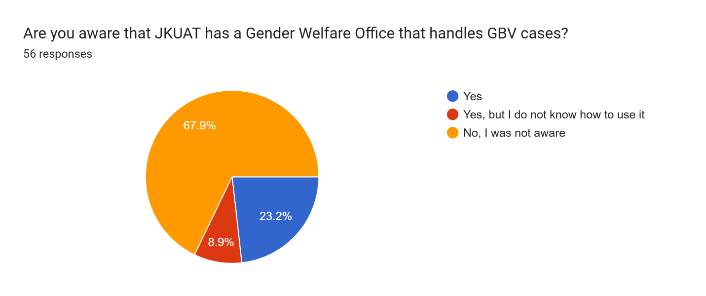
Figure 1: Student Awareness of JKUAT's Gender Welfare Office

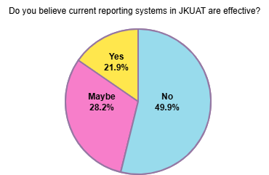
Figure 2: Students’ belief in current reporting systems in JKUAT University
Reporting Behavior and Barriers
Analysis of reporting patterns reveals:
- 81% of students who had witnessed or experienced a GBV incident stated they did not report it through official channels.
- 33.3% cited fear of judgment or victim-blaming as the primary barrier.
- 43.3% stated they did not know where or how to report an incident.
- 23.3% feared retaliation from the perpetrator.
- Approximately 71.9% of survey respondents indicated they would be more likely to report a GBV incident if the process were anonymous and accessible from their mobile device.
- 49.9% of students do not think the current reporting mechanisms are effective.
- Around 67.9% of respondents were unaware of the formal reporting process at JKUAT's Gender Office.
- Lastly,
These findings validate the problem statement's identification of stigma friction, lack of awareness on existing systems and system fragmentation as the primary drivers of the JKUAT underreporting crisis. The low institutional awareness highlights the need for a digital, always-accessible system that does not require prior knowledge of university administrative structures.

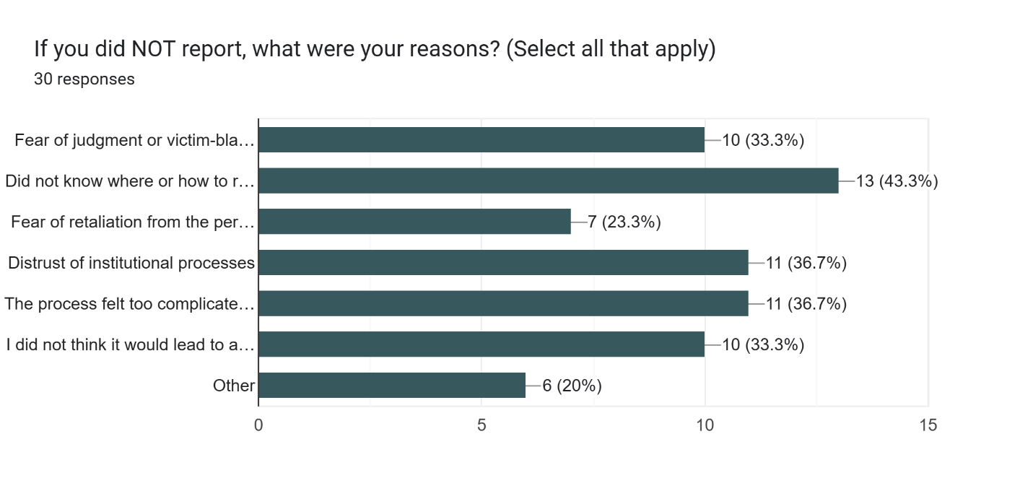
Figure 3: Barriers to Effective GBV Reporting Among JKUAT Students
Technology Acceptance and Preferred Features
Key findings regarding technology acceptance:
- 71.9% of respondents stated they would be more likely to report a GBV incident if the process were anonymous and accessible from their mobile device.
- 40.4% stated they would use an AI counseling chatbot for immediate emotional support if it were available 24/7.
- 75.4% stated a simple one-tap SOS button would be most ideal to use for the system and it will increase their confidence in using a digital GBV reporting system.
This distribution directly informed the design of the one-tap emergency SOS Button, real-time alerts, case management reporting module, AI counselling interface and anonymity as the core requirement.
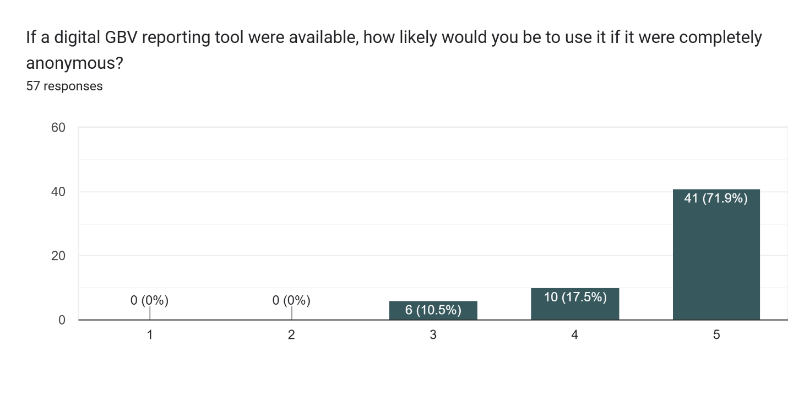
Figure 4: Anonymity Preference Among JKUAT Students.
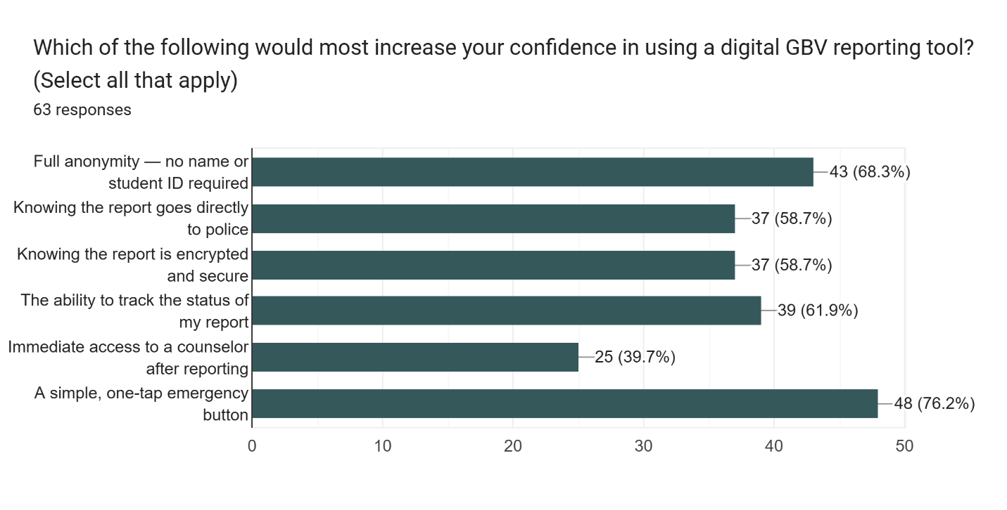
Figure 5: Key Features That Would Increase JKUAT Students' Confidence in Using a Digital GBV Reporting Tool.
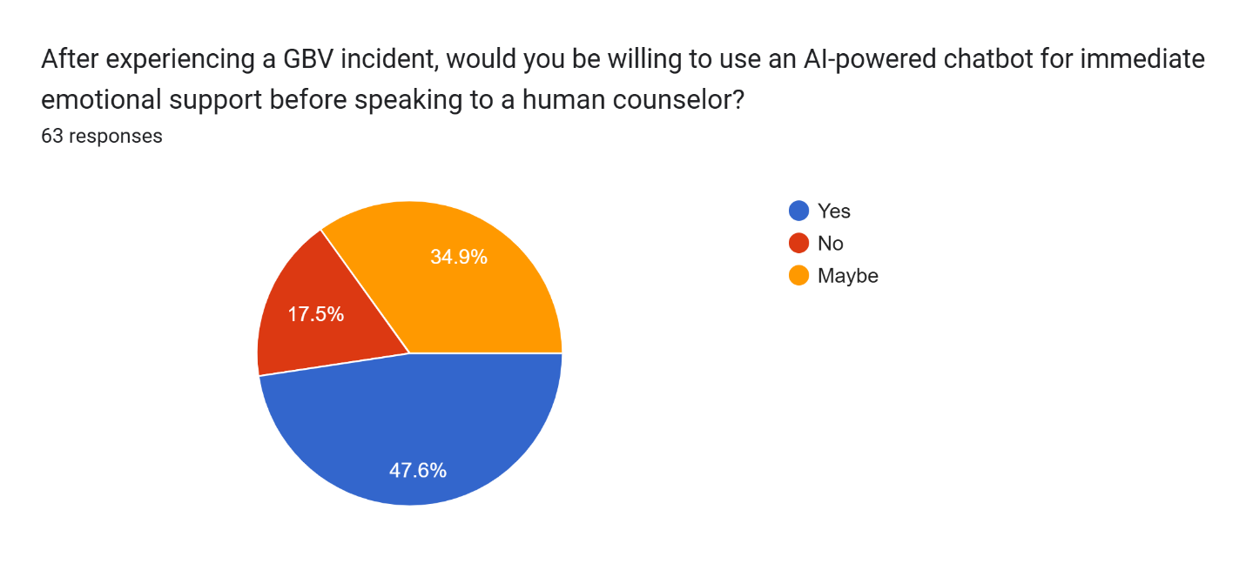
Figure 6: Students’ willingness to use an AI-powered chat bot for emotional support

3.5.2 GBV Office, Campus Security and Juja NPS Analysis
The interview data from JKUAT Gender Office, Juja NPS and campus security officers revealed critical operational gaps:
- Fragmented inter-agency communication: They all receive alerts from different sources with inconsistent incident data. The lack of integration between institutions delays reporting.
- Delayed evidence collection: report form processing introduces significant lag between incident and documentation, reported by 90% of GBV Office staff and 70% of Juja NPS officers which makes it difficult to act on a case due to lack of sufficient evidence.
- Absence of real-time location data for emergency dispatch reported by 70% of campus security officers and 71.2% of Juja NPS officers.
- Inadequate post-incident psychological first aid capacity during out-of-office hours reported by the school counselor.
- The GWO cited fear of coming forward to report as the main barrier to effectively reporting a case, many fear lack of confidentiality, stigma and being judged.

Technology Acceptance and Preferred Features
The highest-rated features among institutional stakeholders were:
- Real-time GPS-based location of SOS activations on a live map.
- Simultaneous multi-party alert delivery to GWO, security and Juja NPS in a single trigger.
- 24/7 AI-powered counseling module to bridge out-of-hours support gaps.
- Creating awareness on the GBV reporting app as well as the Gender Office so that students are aware of current reporting mechanisms in the University.

3.5.3 System Requirements Analysis
Statistical analysis of the requirements data from the stakeholders revealed these primary needs:
Survivors (JKUAT Students), Gender Welfare Office and School Counselor:
- Anonymous, judgment-free reporting mechanism.
- One-tap SOS emergency trigger operable during an active threat.
- 24/7 AI counseling and legal guidance without requiring a human counselor to be available.
- Ability to report and confirm their report was received without revealing their identity.
- Secure case management dashboard with role-based access to the GWO to access reported cases and incident data (100%).
Campus Security and Juja NPS Officers:
- Real-time SOS alert and GPS pin on a live map upon SOS activation.
- Simultaneous alert to Juja NPS without requiring a manual phone call.
- Stand-down protocol to safely deactivate tracking when survivor is confirmed safe (100%).

3.6 SYSTEM SPECIFICATION

3.6.1 Functional Requirements
The following functional requirements define what the system must do, derived from the data collected in Section 3.4 and aligned with the specific objectives stated in Chapter 1.
User Reporting and SOS
- The system shall allow survivors to submit a GBV incident report anonymously using a pseudonymized case ID without requiring personal login credentials.
- The system shall provide a one-tap SOS emergency button that simultaneously transmits an encrypted alert, GPS coordinates, and the device's unique session ID to the JKUAT Security Dashboard and the Juja NPS Dispatch Portal within 3 seconds of activation.
- The system shall maintain a live state loop that continuously pings the GPS location of the SOS-activated device and updates the real-time map on the administrator dashboard until the stand-down protocol is triggered.
- The system shall enable the GBV Office administrator to view, manage, and update the status of all active cases from a secure web-based dashboard with Role-Based Access Control (RBAC).
- The system shall generate and store immutable, timestamped incident logs in the cloud database upon report submission to preserve evidentiary integrity.
- The system shall provide a stand-down protocol allowing authorized personnel to deactivate tracking, notify all parties that the survivor is safe, and archive the case securely.
- The system shall provide a knowledge hub containing links to legal resources, counseling services, and GBV policy documentation accessible to all authenticated users.

Alert Distribution
- The system shall push a WebSocket alert to the Campus Security Dashboard and Juja NPS displaying the GPS location pin and the SOS alert.
- The system shall notify the GBV Office dashboard of an active case with relevant incident metadata.
- The system shall maintain a live GPS tracking loop, updating the location on all active dashboards every 30 seconds until stand-down.

LLM Counseling Module
- The system shall activate an LLM-powered counseling chatbot automatically upon user prompt.
- The system shall constrain all AI counseling responses to a system prompt grounded in the Kenya Sexual Offences Act, JKUAT Gender Policy and rule-based logic.
- The system shall monitor counseling conversations for high-risk escalation indicators and trigger a notification to the rule-based NLP logic layer when detected.

Case Management and Administration
- The system shall generate and store immutable, WORM-compliant, timestamped incident logs upon report submission.
- The system shall enforce Role-Based Access Control (RBAC), ensuring the GWO access a reported case while security access emergency alerts only.
- The system shall provide a stand-down protocol enabling authorized officers to stop tracking, notify all parties, and archive the case.
- The system shall provide a Knowledge Hub containing links to legal resources, counseling services, and GBV policy documentation.

3.6.2 Non-Functional Requirements
Security and Confidentiality Requirements:
- The system shall encrypt all data in transit using TLS 1.3 and all data at rest using AES-256.
- The system shall implement Role-Based Access Control (RBAC) enforced via Firebase for all system functions to ensure that police, security, and GBV administrators only access the data relevant to their operational role.
- The system shall maintain complete separation between survivor identity and incident content through pseudonymization using UUID case identifiers.
- The system shall implement WORM immutable cloud storage for all incident reports and audit logs.
Performance Requirements:
- The SOS alert shall be delivered to all designated recipients within 3 seconds of trigger activation under standard network conditions.
- The system shall support at least 50 concurrent SOS activations without degradation of alert delivery speed leveraging the auto-scaling capabilities of the serverless cloud infrastructure.
- The system shall maintain availability of 99% leveraging managed cloud infrastructure availability guarantees.
- The system shall scale automatically during peak periods such as university events without manual provisioning.
Usability Requirements:
- The SOS trigger shall be operable with a maximum of two taps from the landing screen under distress conditions, consistent with the Technology Acceptance Model's emphasis on perceived ease of use.
- The system shall be fully functional on both desktop and mobile web browsers without requiring app installation.
- The system shall provide clear, non-judgmental language throughout all survivor-facing interfaces.
Availability and Reliability Requirements
- The system shall retain the last successfully captured GPS coordinates with a staleness timestamp if the live location ping fails.
- The system shall recover from cloud function failures without data loss through idempotent event processing.
Scalability Requirement
  - The system must be designed to scale horizontally to accommodate increased usage during peak periods such as university events or heightened campus activity, without requiring manual infrastructure provisioning.

3.7 REQUIREMENT ANALYSIS AND MODELING

3.7.1 Use Case Diagram
The system serves four primary actors: the Survivor (JKUAT student), Campus Security Officer, Gender Welfare Office Administrator and Juja NPS Officer.
The main use cases are: Activate SOS Button, Submit Anonymous Report, Receive Emergency Alert, Monitor Live Location, Locate the survivor and take action, Engage LLM Counseling Chatbot, Manage Case Dashboard, Trigger Stand-down Protocol, and Access Knowledge Hub. The relationships between these actors and use cases reflect the multi-tiered, asynchronous response architecture described in Section 1.4 and the SOS Button mind map.
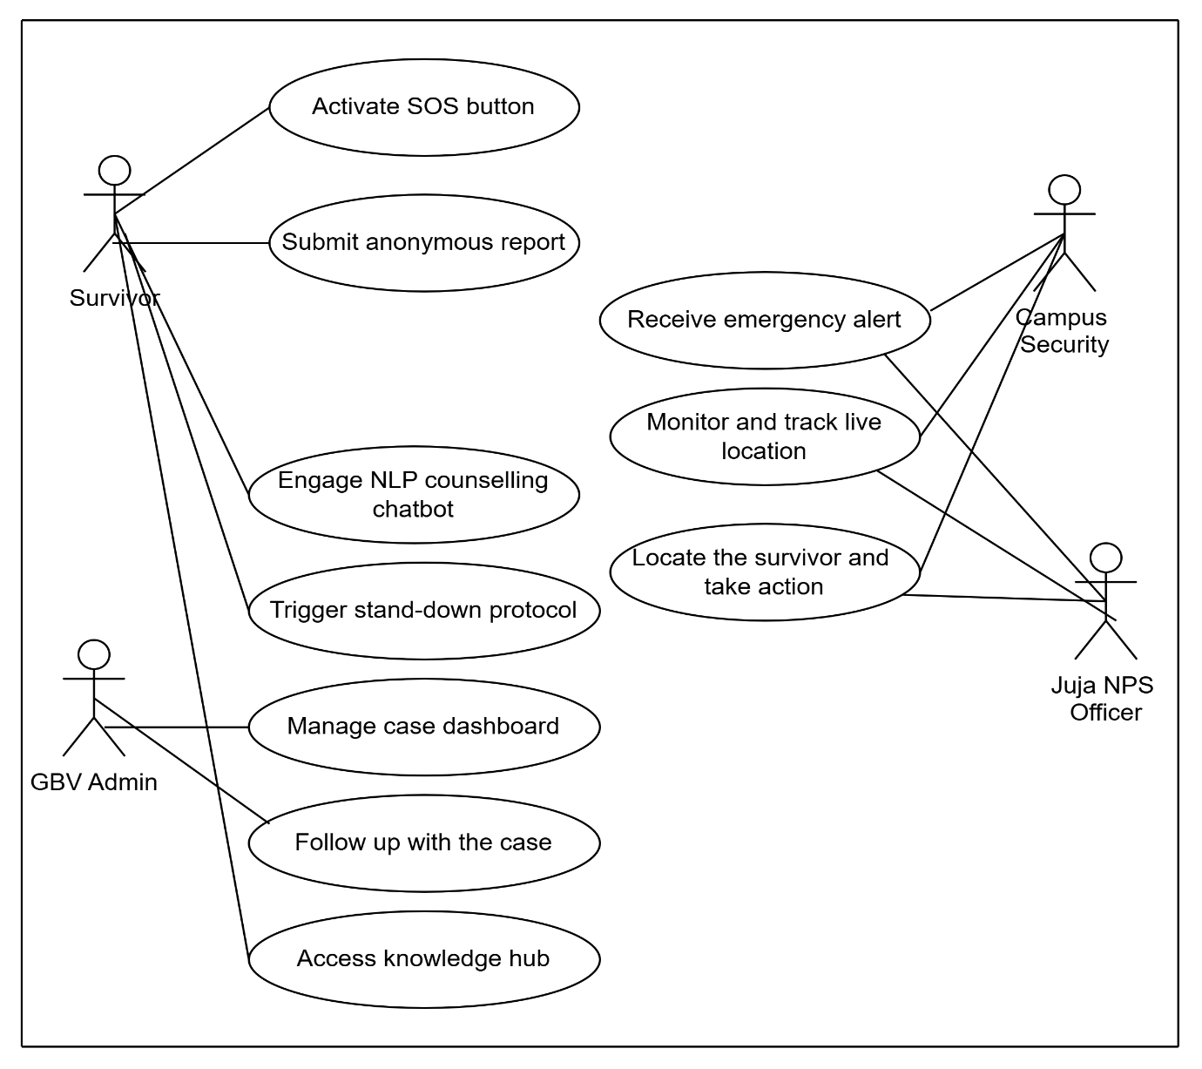
Figure 7: Use Case Diagram Illustrating Interactions Between Survivors, GWO, Juja NPS and Campus Security.

3.7.2 Data Flow Diagram (DFD) – Level 0 (Context Diagram)
The context diagram defines the system boundary and the external entities that interact with it. The central system process is the AI-Driven GBV Reporting and Counseling Engine. The four external entities are the Survivor, the Campus Security, the Juja NPS and the GWO. The survivor sends in an SOS event or incident report and receives counseling support and acknowledgement. The backend engine processes the event and distributes alerts, location data and case records to the respective authority dashboards in real time.
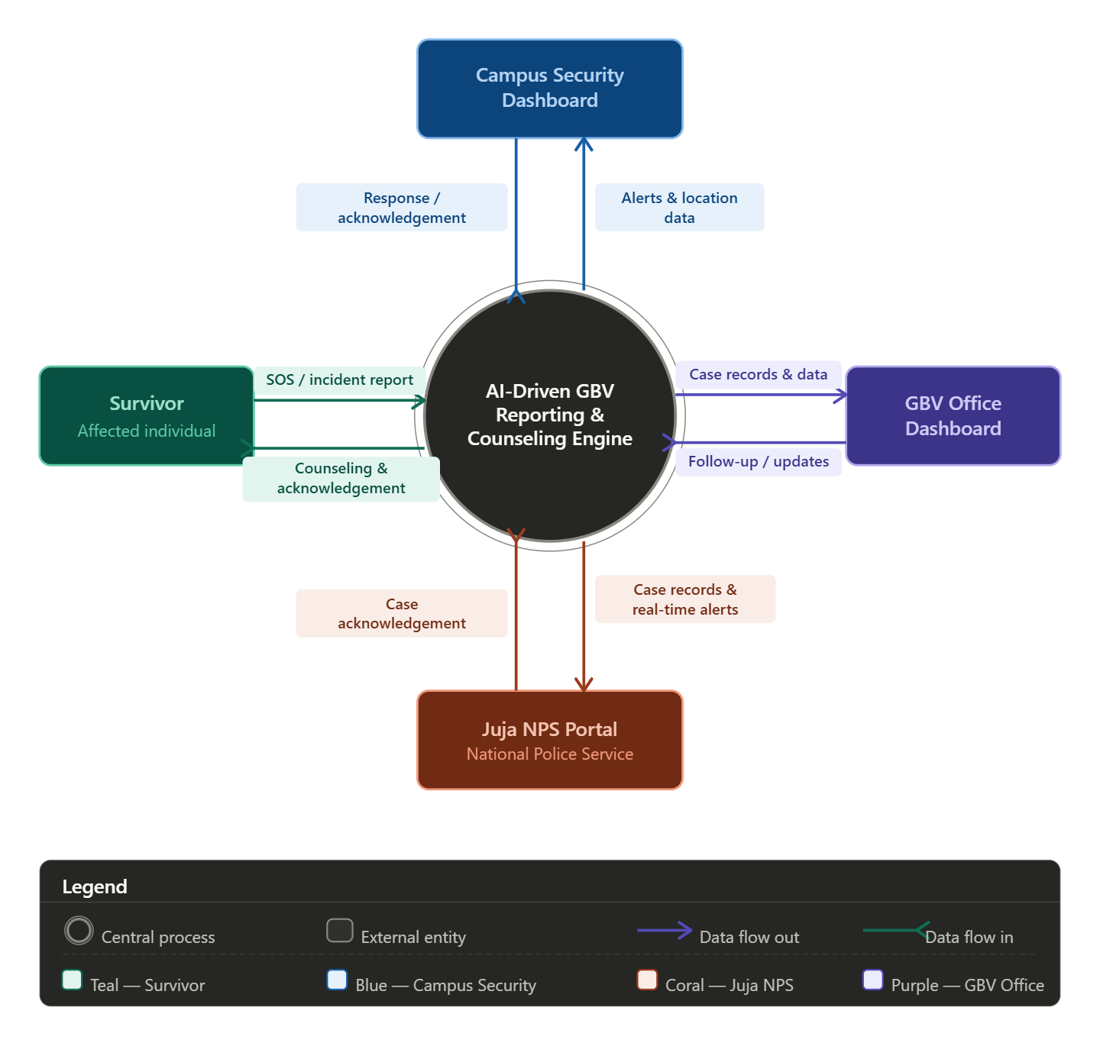
Figure 8: Data Flow Diagram Illustrating Relationships Between Internal and External Entities of the System.

3.8 LOGICAL DESIGN

3.8.1 System Architecture
The system adopts a Three-Tier Architecture consistent with the architectural model identified as best practice in Chapter 2. The three tiers are as follows.
Tier 1 – Presentation Layer: A responsive web application built with React.js and styled with Tailwind CSS. This layer handles all user-facing interfaces including the survivor's reporting portal, the SOS button, the LLM counseling interface and the administrator dashboards. The use of a web application rather than a native mobile app ensures cross-platform accessibility without requiring installation, reducing the barrier to use during an emergency.
User interfaces for different stakeholder groups:
- Survivor web interface- anonymous report form, SOS Button, LLM counseling chat.
- Campus Security & Juja NPS dashboard- live GPS map, SOS alert, stand-down controls.
- GWO dashboard- case management.

Tier 2 – Application Logic Layer (Middleware): A serverless backend comprising Google Cloud Functions that processes events asynchronously. WebSockets are used to establish real-time location loop and dashboard updates. The Google Gemini API is called from this layer to power the LLM counseling chatbot, with a custom system prompt enforcing the Kenyan Sexual Offences Act, JKUAT Gender Policy and rule-based logic as the knowledge boundary.
Tier 3 – Core Data Layer (Backend): It will consist of a Firebase database extended with its geospatial module for GPS data management. Immutable cloud storage is used for incident reports and audit logs. Role-Based Access Control (RBAC) is enforced at the database query level to ensure data isolation between the police, security and GWO administrator roles.

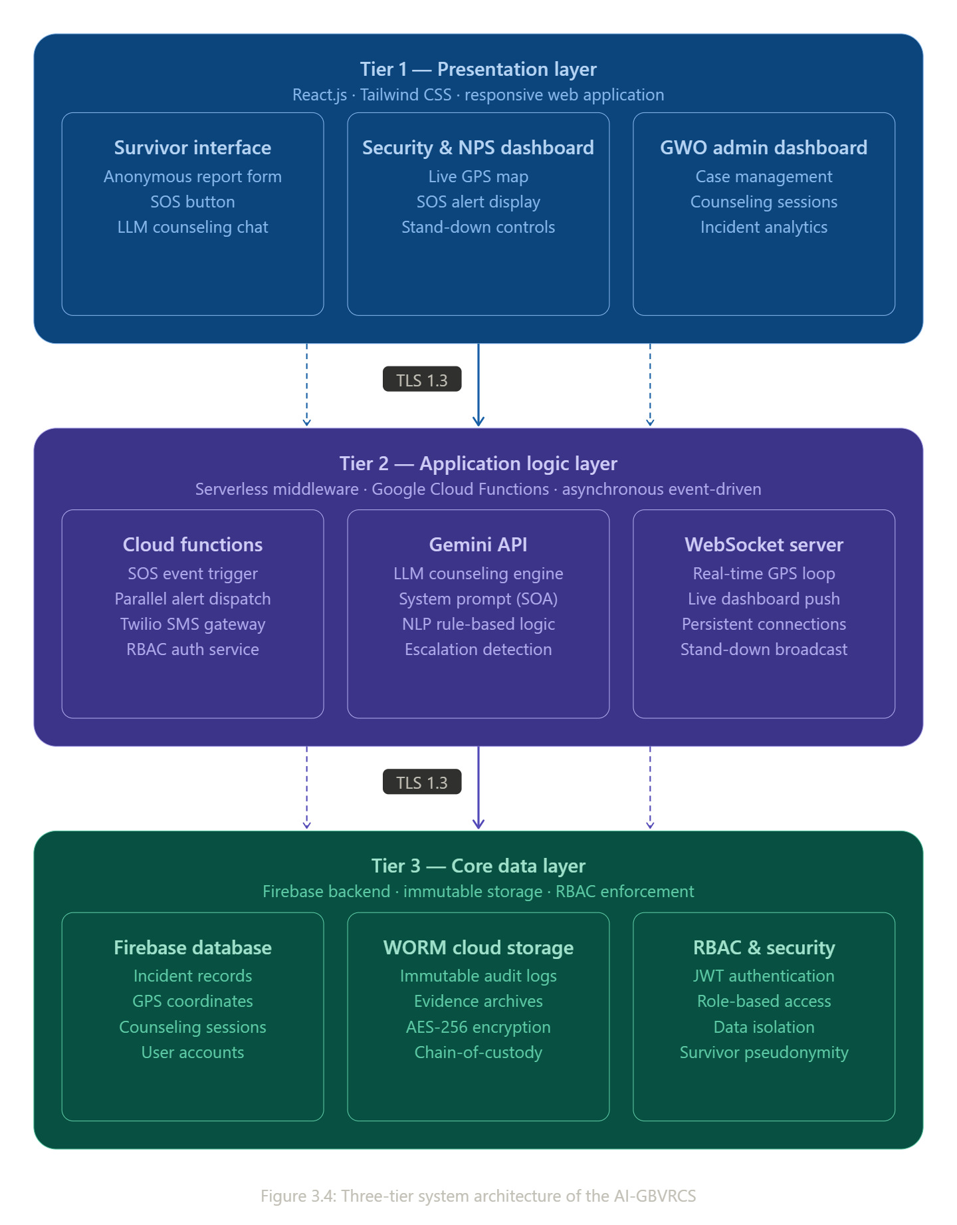
Figure 9: Illustration of the Three-tier System Architecture

Key architectural considerations:
- Separation of Concerns: Clean separation between presentation, business logic and data access layers
- Event-Driven Design: The SOS Button triggers parallel asynchronous cloud functions, eliminating sequential bottlenecks of traditional request-response architectures.
- Secure Communication: TLS 1.3 encrypted data transfer between all layers.
- Stateless Serverless Design: Maintaining all application state in the data layer enables horizontal scaling and zero-downtime deployments.

3.8.2 Control Flow and Process Design
SOS Button Trigger Flow
The following describes the control flow of the core SOS Button process, which is the most critical feature of the system:
- The survivor presses the SOS Button on the web application interface.
- The application layer captures the device's GPS coordinates, generates a unique encrypted Session ID, and creates a timestamped incident record.
- A UI alert is displayed on the survivor's screen confirming the SOS has been activated.
- The event is transmitted to the serverless backend trigger function. The backend trigger invokes four parallel asynchronous cloud functions simultaneously:
- WebSocket push to the Gender Welfare Office, Campus Security and Police dashboards displaying an SOS alert and the GPS pin.
- WebSocket push to the Gender Welfare Office dashboard showing active case detail.
- Immutable write to the Firebase database creating the incident record.
- The Live State Loop begins: the device pings GPS coordinates every 30 seconds and the server updates the live map on all active dashboards.
- Upon resolution, an authorized officer or victim activate the Stand-down Protocol, which stops tracking, sends a "safe" notification to all parties, and archives the case record

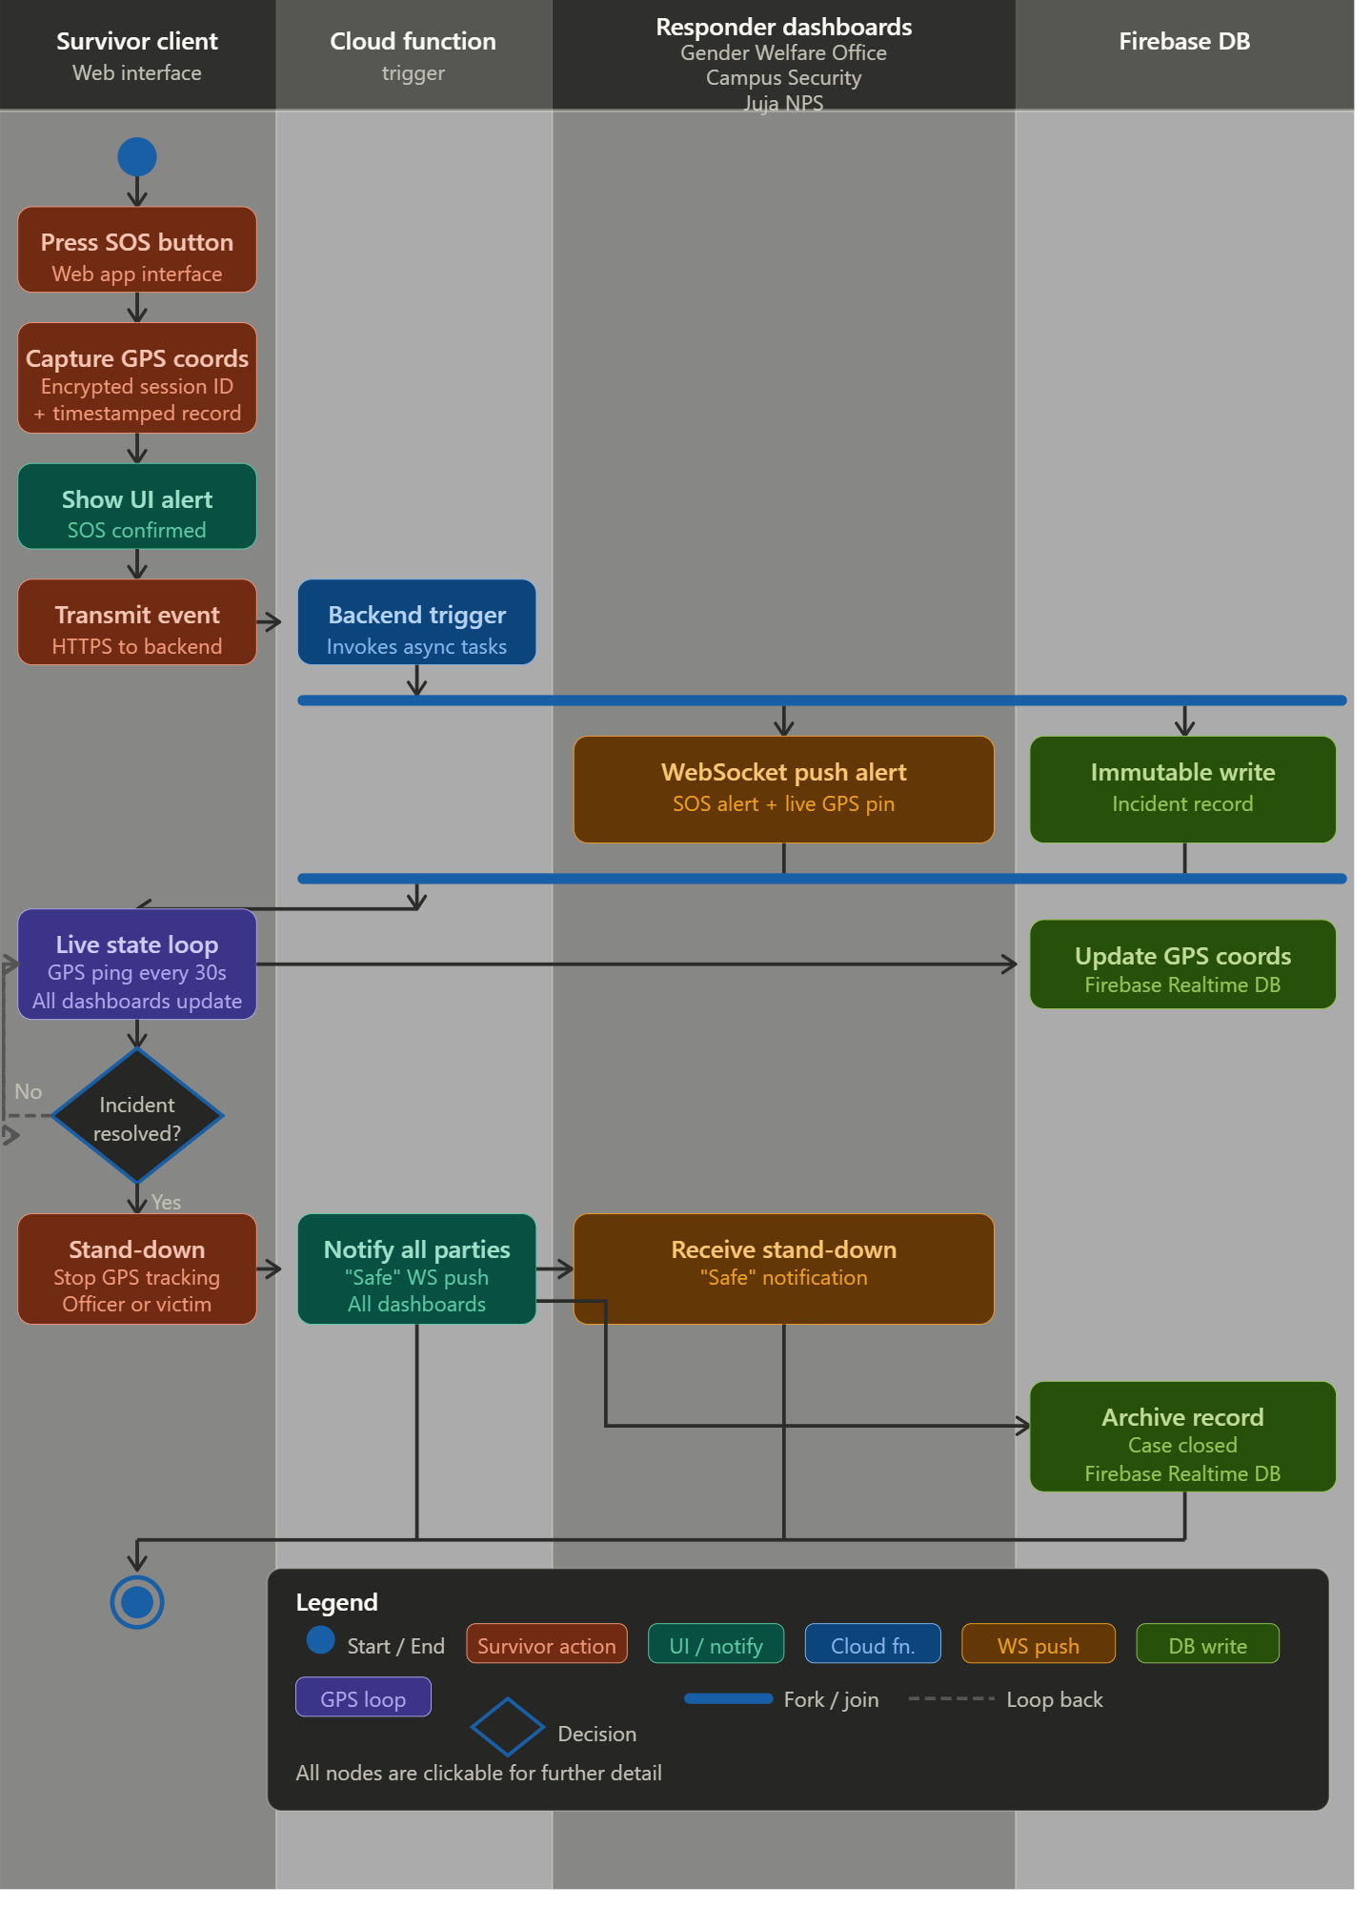
Figure 10: Acivity Diagram Illustrating the SOS Button Trigger Process Flow

LLM Counseling Module Flow
The survivor's text input is passed to the Google Gemini API via a structured API call. The AI response is streamed back to the survivor's interface in real time using server-sent events. A structured escalation flag within the AI logic monitors the conversation for high-risk indicators such as suicidal ideation or immediate physical danger, and triggers the rule-based backend NLP layer to validate LLM outputs, enforce predefined system rules and guide critical decision-making processes.
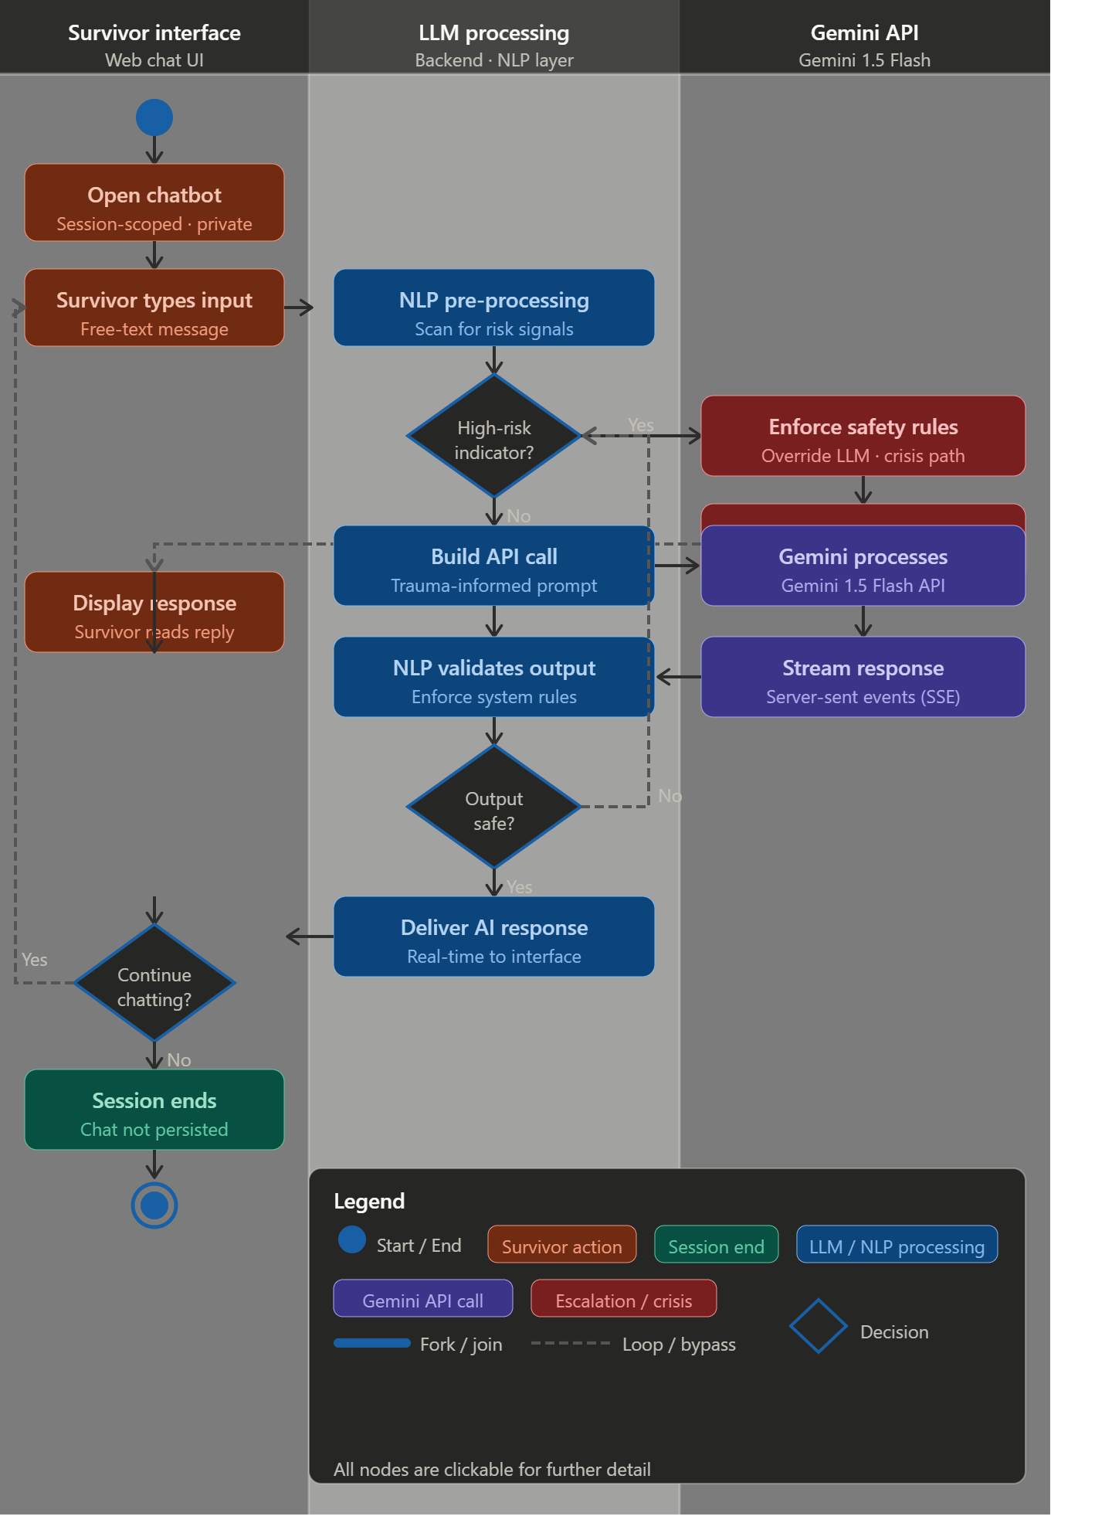
Figure 11: Activity Diagram Illustrating the Anonymous Reporting and LLM Counseling Process Flow

Reporting Process Flow:
The victim has an optional evidence upload step. If the uploaded file does not meet the required format or size constraints, the system prompts the victim to retry until a valid file is submitted. The encrypted report is then written to Firebase Firestore with the recipient type set to Gender Office. The Gender Office administrator receives an instant dashboard notification and assigns a case worker to progress the matter. Simultaneously, the victim receives a confirmation of their submission, displaying only their case ID, giving them a reference point without compromising their anonymity at any stage of the process.
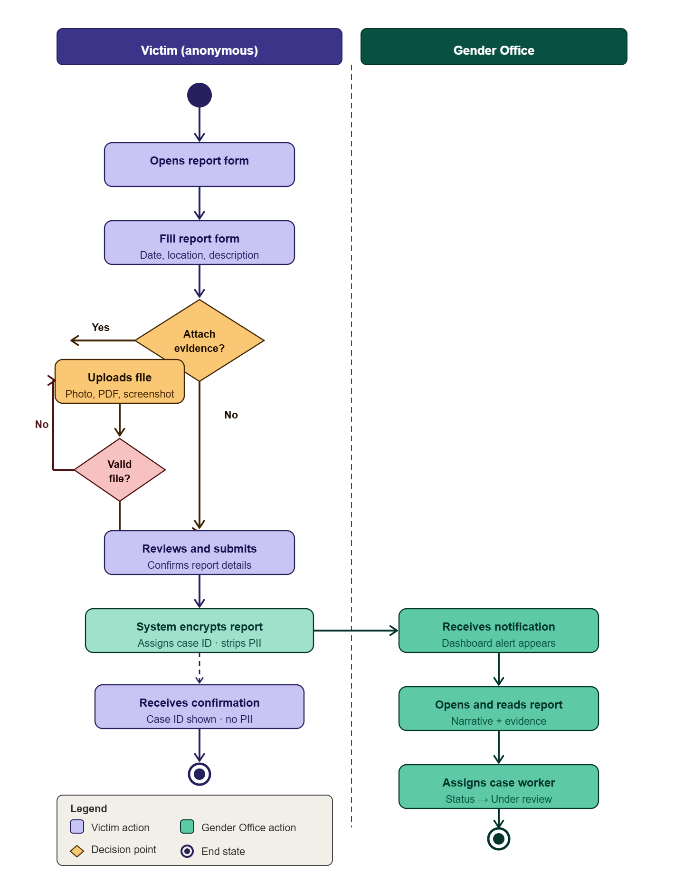
Figure 12: Activity Diagram Illustrating the Stand-down Protocol Process Flow

3.8.3 Design for Non-Functional Requirements
Security Design:
Authentication Security:
- Bcrypt or PBKDF2 password hashing with individual salts for all administrator accounts.
- Survivor pseudonymization — UUID case IDs replace all personal identity markers from the point of submission.

Authorization Framework:
- Role-Based Access Control (Survivor, Campus Security Officer, GWO Admin, Juja NPS Officer).
- Fine-grained database partition isolation between counseling data, report data and evidence data.
- Principle of least privilege implementation.
Data Protection:
- End-to-end TLS 1.3 encryption for all data in transit.
- AES-256 encryption for all data at rest.
- Immutable storage preventing administrator deletion of submitted evidence.
Network Security:
- TLS/SSL for all communications between client, server, and third-party APIs.
- API rate limiting and request validation at the cloud function gateway to prevent denial-of-service attacks on the SOS trigger endpoint.
- Web application firewall implementation.

Error and Exception Handling
Each cloud function includes a try-catch wrapper that logs failed execution events to a dedicated error monitoring service. If the GPS ping fails, the last successfully captured coordinates are retained and displayed with a staleness timestamp on the dashboard.
Survivor-Facing Errors:
- Non-intrusive status indicators for connectivity issues that do not disrupt the SOS activation flow.
- Trauma-sensitive, calm error messaging- never exposing technical details to the survivor during a crisis interaction.
System Error Management:
- Comprehensive cloud function error logging to a dedicated monitoring service.
- Retry logic with exponential backoff for failed GPS pings to prevent server overload.
Performance Optimization: Cloud functions are pre-warmed during high-traffic periods such as weekends and university events to eliminate cold-start latency. Database queries for the live location loop are optimized using Firebase spatial indexes to ensure sub-second retrieval of GPS coordinates.

3.9 PHYSICAL DESIGN

3.9.1 Database Design
The system employs a hybrid data storage approach:
Immutable Cloud Storage: For tamper-proof incident records and audit logs
- WORM-compliant storage buckets on Firebase Google Cloud for submitted evidence.
- Timestamped audit trail logs capturing every system action with actor role and timestamp.
The physical database is implemented in Firebase. The core entities and their relationships are described below.
Relationships
Relationship 1: Incident to Alert_Log: One-to-Many
The Incident table is the central entity. Each Incident can have multiple Alert_Log records. One incident can generate many alert log records, but each alert log record belongs to exactly one incident. When a victim presses the SOS button, it creates a single Incident record but the system dispatches that alert to three separate recipients; GWO Admin, Campus Security and the Police. Each of those dispatches create their own separate row in Alert_Log, recording who it was sent to, how it was delivered, at what time, and whether it succeeded or failed. So one SOS event produces three Alert_Log entries.
The 0..* on the Alert_Log side means zero or more, because a report submitted without an SOS would not generate any alert logs at all, so the minimum is zero, not one.The foreign key incident_id in Alert_Log enforces this pointing back to the parent Incident, linking every alert record to the event that caused it.
Relationship 2: Incident to Counseling_Session: One-to-One
This is a one-to-one relationship. One incident can be linked to at most one counselling session, and one counselling session can be linked to at most one incident. The 0..1 on the Counselling_Session means the counselling session is optional. A victim might press SOS or file a report without ever opening the chatbot, so an incident can exist with no counselling session.
Equally, a victim might open the AI chatbot and talk without ever filing a formal report, in that case a Counseling_Session record exists with a nullable incident_id (as marked «FK, nullable» in the diagram), meaning the foreign key field is left empty. Therefore, the relationship works in both directions: an incident may or may not have a session, and a session may or may not be linked to an incident.

Relationship 3: Users to Incident, Alert_Log, and Counseling_Session: Dependency (not a true association)
The Users table is independent of the Incident table to ensure that survivor reports cannot be linked to a specific administrator's access log, preserving confidentiality. Instead, access is enforced externally via Firebase Security Rules / RBAC to preserve the confidentiality firewall between access logs and survivor records. That’s why users use dependency arrows and not association arrows.
When a GBV Admin logs in, Firebase checks their role token and decides what collections they are permitted to read. This happens at the infrastructure level, outside the data itself. The dashed arrows in the diagram represent this: Users can interact with those tables through the application, but there is no structural database link between them. Therefore, users have no foreign key into any of the other three tables, and none of the other three tables have a foreign key pointing to Users for privacy.
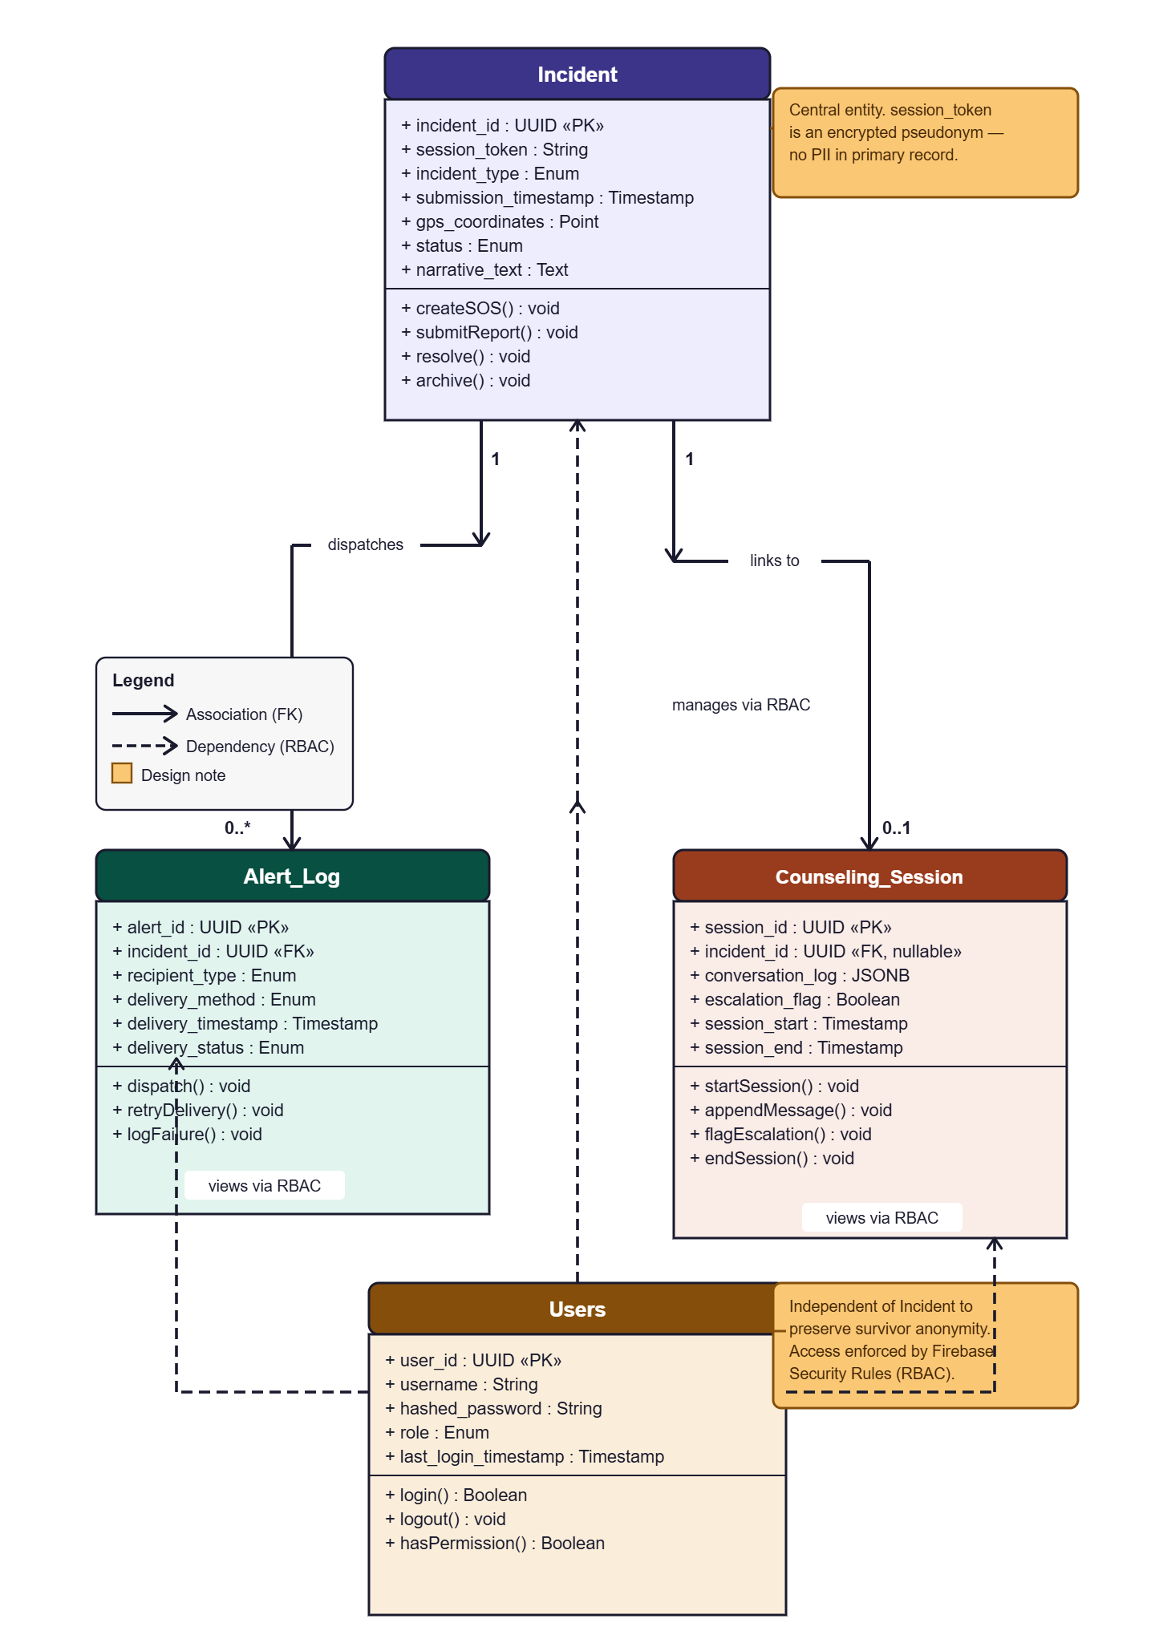
Figure 13: Physical Database Schema Summary Class Diagram

3.9.2 User Interface Design
The user interface is designed in adherence to the Technology Acceptance Model's emphasis on perceived ease of use and the Survivor-Centered Framework's requirement for low-friction, non-judgmental interaction. Wireframes for the key screens were developed using Figma and are described below.
Survivor Landing Screen Wireframe: The home screen presents a minimal interface with two primary elements: a large, prominently positioned SOS Button in red, and secondary options of reporting.
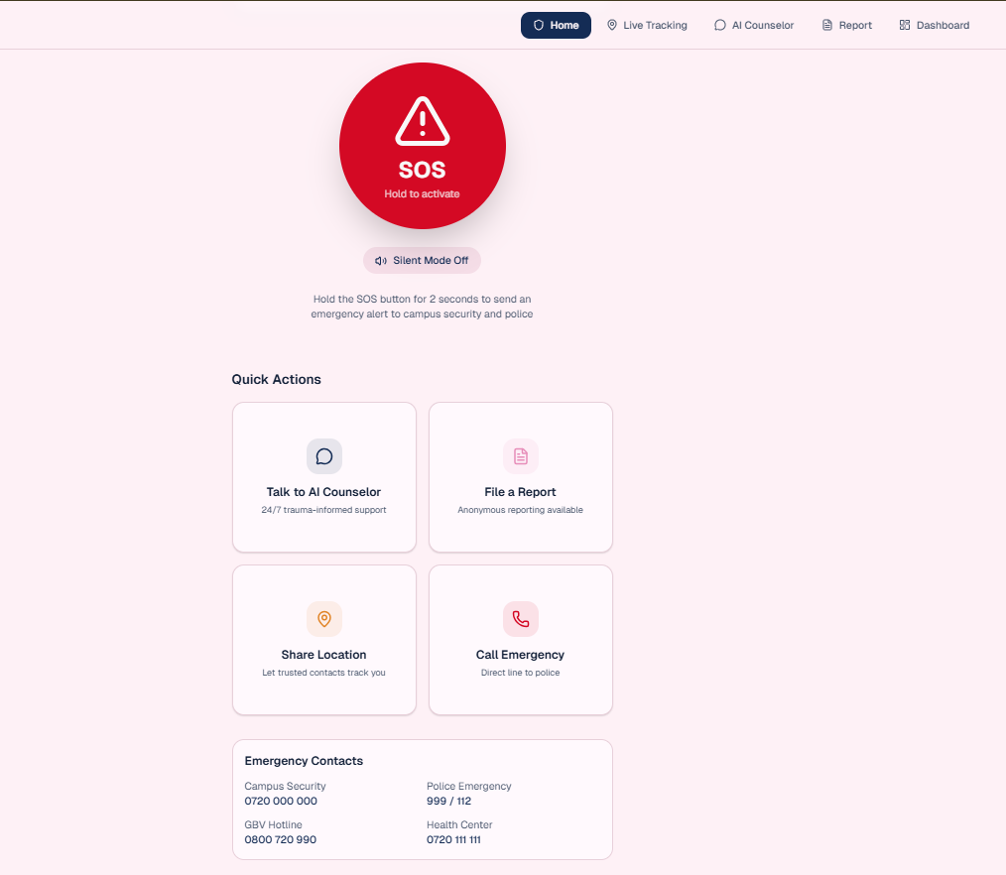
Figure 14: Survivor Landing Screen Wireframe
Anonymous Report Form Wireframe: A structured, multi-step form that guides the survivor through incident type selection, optional location sharing, optional narrative text input, and submission. Each step is presented on a separate screen to avoid overwhelming the user. The form does not request any personally identifiable information.
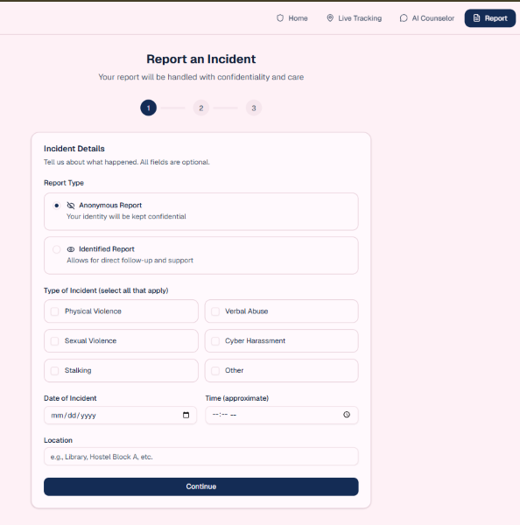
Figure 15: Anonymous Report Form Wireframe

LLM Counseling Interface Wireframe: A clean chat-style interface that activates automatically a user prompts it. The interface supports text input and uses streaming server-sent events to display the AI's response token by token, creating a natural conversational feel that reduces perceived latency.
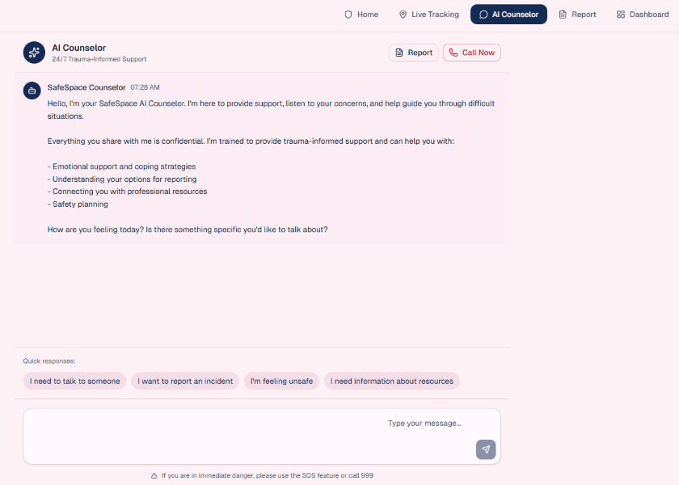
Figure 16: LLM Counseling Interface Wireframe

Campus Security Dashboard Wireframe: A real-time map-centric interface displaying the live GPS location of any active SOS event. A sidebar lists all active and recent cases with status indicators. Officers can update case status and trigger the stand-down protocol by marking the case “resolved” from this dashboard.
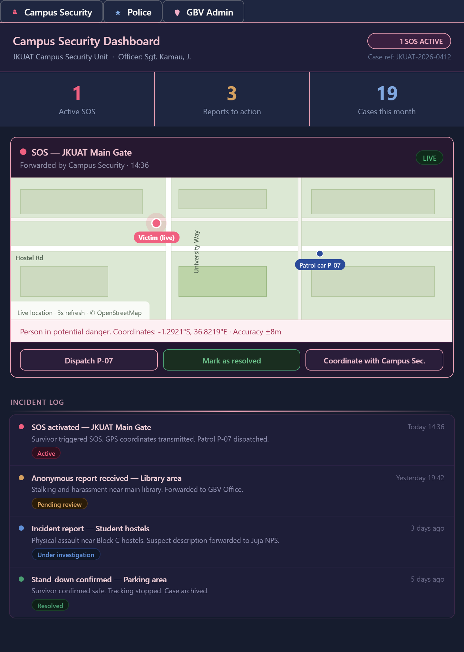
Figure 17: Juja NPS Dashboard Wireframe

Juja NPS Dashboard Wireframe: A real-time map-centric interface displaying the live GPS location of any active SOS event. A sidebar lists all active and recent cases with status indicators. Officers can update case status and trigger the stand-down protocol by marking the case “resolved” from this dashboard.
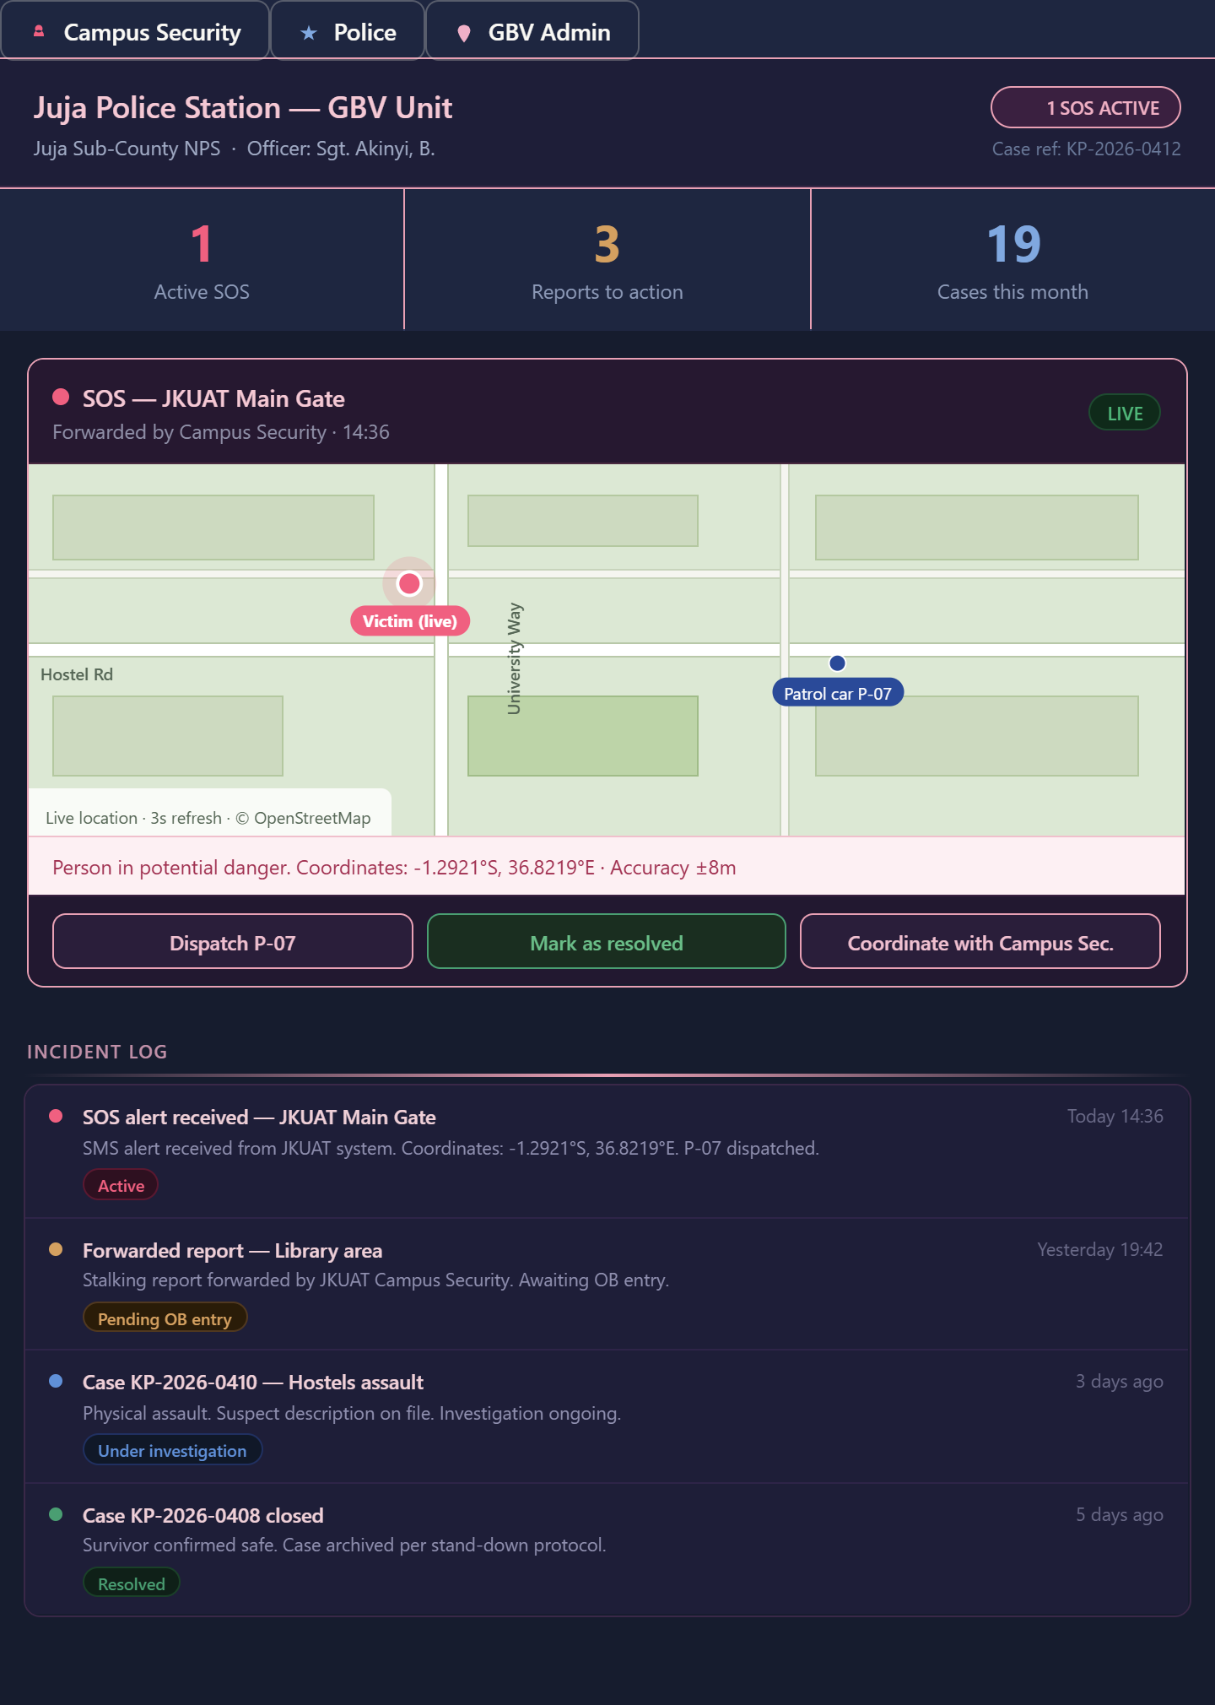
Figure 18: Juja NPS Dashboard Wireframe
Gender Welfare Office Dashboard Wireframe: A case management interface presenting active case reports, visible to GBV Admin only.
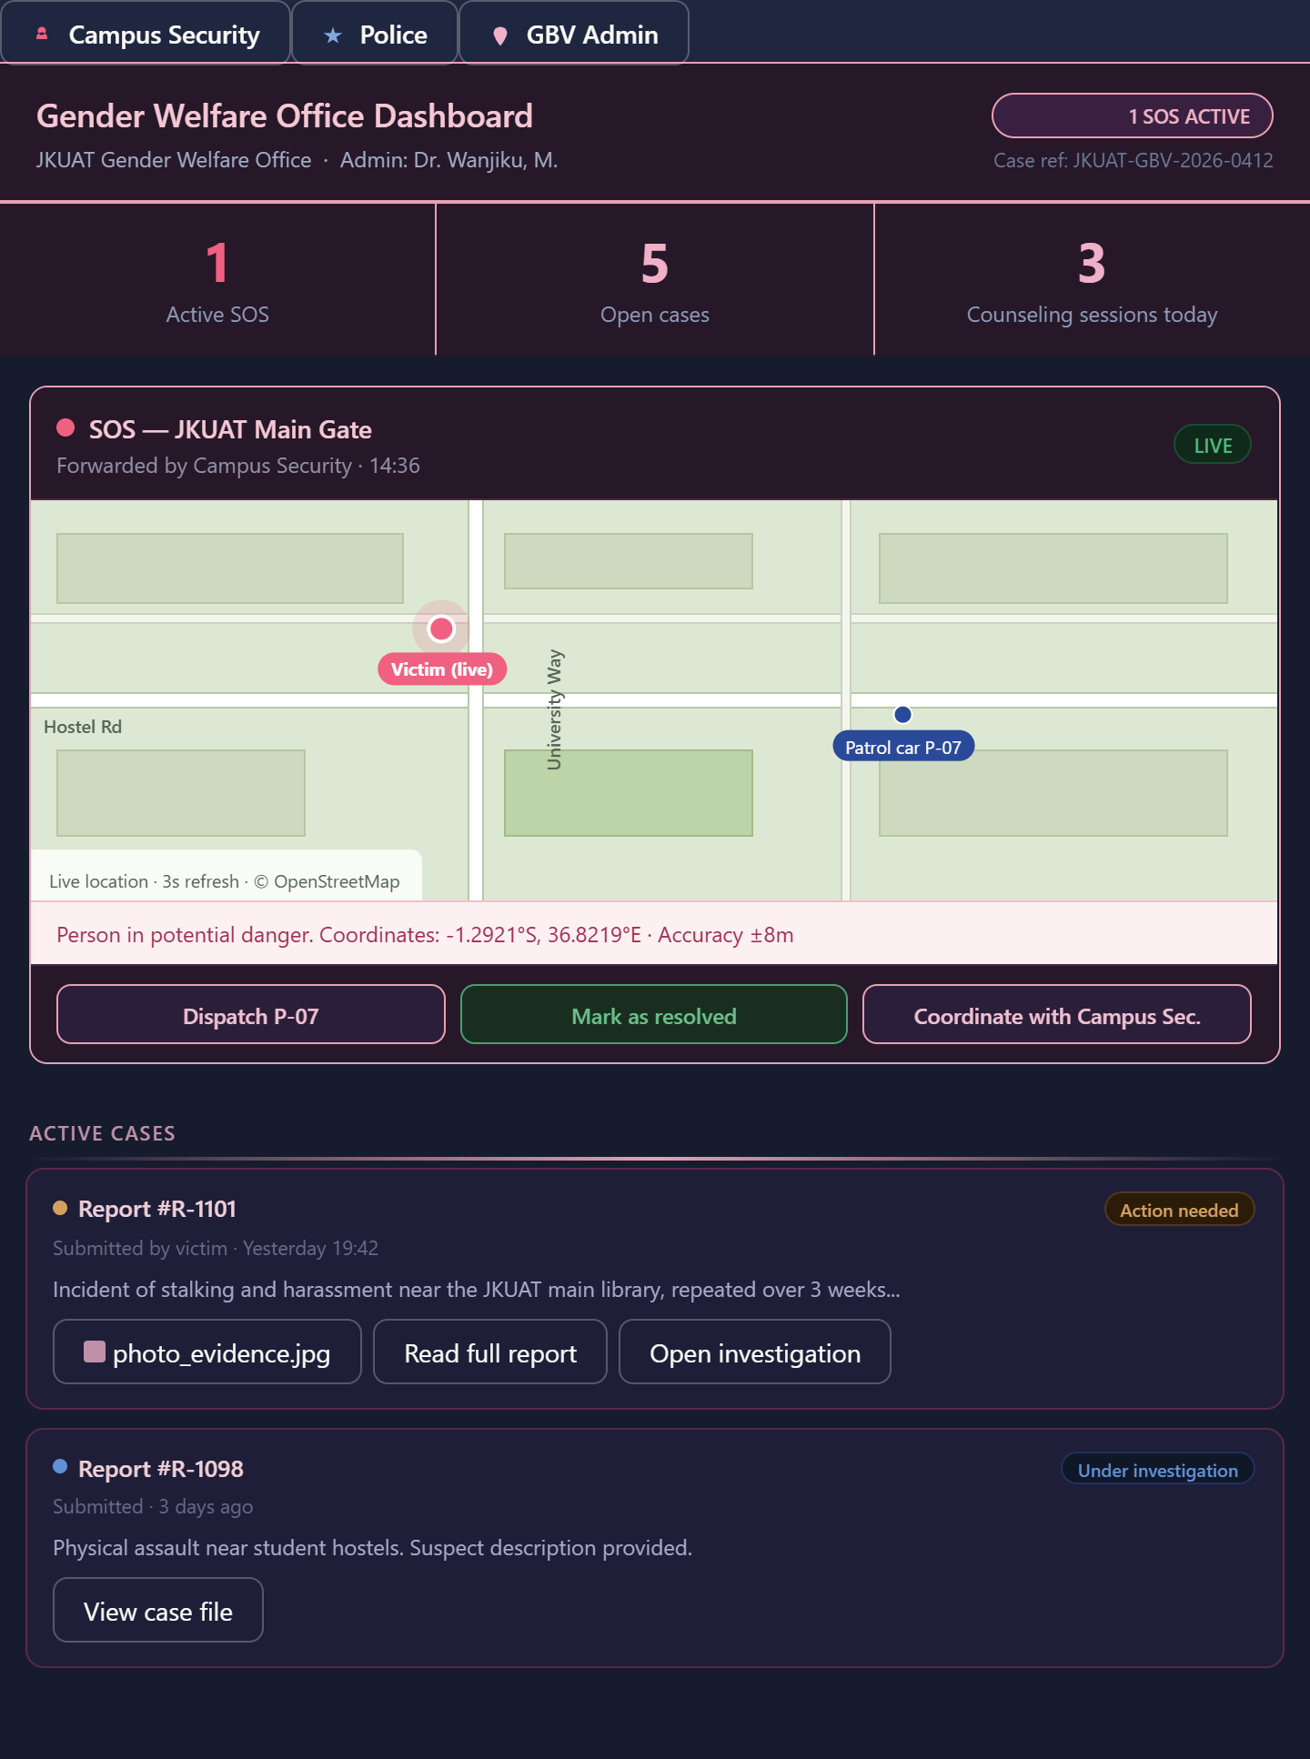
Figure 19: GWO Dashboard Wireframe

REFERENCES
Bott, S., Guedes, A., Ruiz-Celis, A., & Mendoza, J. A. (2021). Intimate partner violence in the Americas: A systematic review and reanalysis of national prevalence estimates. The Lancet Regional Health – Americas, 1, 1–9.
Davis, F. D. (1989). Perceived usefulness, perceived ease of use, and user acceptance of information technology. MIS Quarterly, 13(3), 319–340.
Global Campus Safety Network. (2022). Campus safety management and reporting best practices. https://www.globalcampussafety.org/resources/best-practices
International Telecommunication Union. (2023). Digital safety for women: Global trends in tech-facilitated GBV response. United Nations.
Kamau, W., & Njuguna, A. (2021). Barriers to reporting gender-based violence in Kenyan universities: An assessment of Moi University. International Journal of Gender Studies, 9(2), 45–59.
Kenya Data Protection Act. (2019). Data Protection Act No. 24 of 2019. Office of the Data Protection Commissioner. https://www.odpc.go.ke/
Kenya National Bureau of Statistics. (2022). Kenya Demographic and Health Survey 2022: Key indicators report. https://www.knbs.or.ke/
Kiilu, H., Nakitto, M., & Tumwine, G. (2020). Mobile SMS interventions in improving GBV reporting in Uganda: A case study. African Journal of Information Systems, 12(3), 67–84.
Ministry of Education Kenya. (2020). National policy for prevention and response to gender-based violence in learning institutions. https://www.education.go.ke/
Muthoni, S., Wambui, P., & Otieno, B. (2022). Awareness of gender-based violence and reporting mechanisms among university students in Kenya: A case of Kenyatta University. Journal of Social Protection and Development, 6(1), 101–120.
Mutisya, E., & Waweru, S. (2019). Mobile technology for community-based GBV surveillance in Nairobi’s informal settlements. Urban Safety Journal, 5(4), 33–50.
Office of the Data Protection Commissioner Kenya. (2024). Data protection regulations and guidance. https://www.odpc.go.ke/
Republic of Kenya. (2022). National Cybersecurity Strategy: Protecting critical information infrastructure. Government Printer.
Supreme Court of Kenya. (2022). Presidential Election Petition No. E005 of 2022: Raila Odinga & Another vs. William Samoei Ruto & Others. Judiciary of Kenya.
Syvertsen, J. L., Geibel, S., et al. (2019). Mobile interventions for sexual violence reporting in South Africa: A feasibility study. BMC Public Health, 19, 1234.
UN Women. (2022). Safe cities and safe public spaces for women and girls global innovative program. United Nations.
UN Women. (2024). Facts and figures: Ending violence against women. https://www.unwomen.org/en/what-we-do/ending-violence-against-women/facts-and-figures
United Nations Population Fund. (2023). Gender-based violence. https://www.unfpa.org/gender-based-violence
Wangu Kanja Foundation & Amref International University. (2024). The silence culture: Prevalence and reporting trends of gender-based violence in Kenyan higher education institutions. Wangu Kanja Foundation.
World Health Organization. (2021). Devastatingly pervasive: 1 in 3 women globally experience violence [Fact sheet]. https://www.who.int/news/item/09-03-2021-devastatingly-pervasive-1-in-3-women-globally-experience-violence
World Health Organization. (2021). Violence against women prevalence estimates, 2018. Geneva: WHO.
World Health Organization. (2023). Violence against women. https://www.who.int/news-room/fact-sheets/detail/violence-against-women

APPENDICES

Appendix A: Proposed Resources
1. Software Resources
Operating System: Microsoft Windows 11
Programming environment: React.js.
Code editor: Google Antigravity
Version Control: GitHub
AI Engine: Google Gemini API for the counseling logic.
Database system: Firebase
Internet: Wi-Fi and data bundles for back-up.

Design Softwares:
- Draw.io and Figma to create system architecture diagrams.
- Microsoft Defender Antivirus for antimalware.
- Microsoft Word for writing and formatting the research proposal and system documentation and final project report.
- Microsoft Excel for organizing datasets, recording evaluation results and performing basic statistical analysis and visualization of system performance metrics.
Presentations: Canva and Microsoft PowerPoint.
  - Human Resources
Lead Developer, Data Scientist, UI/UX Designer, Researcher: Stephanie Wangari
Project Supervisor: Mr. Phillip Oyier
Stakeholders: JKUAT Gender Welfare Office, students of JKUAT university and representative officers from Juja Police Station.

Appendix B: Proposed Budget
Category | Item | Estimated Cost
Cloud Hosting | Google Cloud / AWS (Serverless & AI APIs) | KES 25,000
SMS/Alerts | Twilio API | KES 1500
twiSecurity | SSL Certificates & Advanced Data Encryption | KES 3,000
Hardware | 2 Dedicated Tablets for Juja Police Station Desks | KES 20,000
Internet | Wi-Fi | KES 7500
Printing & Binding | Proposal and Final Report | KES 2000
Marketing | Campus Awareness (Posters, Social Media Ads at JKUAT) | KES 8,000
Total | Approximate Budget | KES 65,600

Table 6: Project Budget

Appendix C: Project Timeline
• Month 1: Sprint 1- stakeholder meetings, legal alignment, data collection and analysis
• Month 2: Sprint 2- UI/UX design, system architecture, Figma wireframes, Firebase cloud setup
• Month 3: Sprint 3- SOS button, GPS capture, encrypted anonymous reporting
• Month 4: Sprint 4- Gemini API integration, NLP rule-based logic, security and GWO dashboards
• Month 5: Sprint 5- RBAC, AES-256, JWT, WORM storage, final database schema and audit log
• Month 6: Sprint 6- UAT with stakeholders, stress testing, AI fine-tuning, final submission

Appendix D: Gantt Chat
Appendix C: Project Timeline — Hybrid Agile-Scrum (6 Sprints × 2 Weeks)
Phase / Sprint | Month 1 | Month 2 | Month 3 | Month 4 | Month 5 | Month 6
Sprint 1  Data Collection & Stakeholder Alignment | Stakeholder meetings  JKUAT GWO · Juja NPS
Sprint 2  UI/UX Design & Cloud Infrastructure |  | UI/UX & Architecture  Figma · DB schema · Firebase
Sprint 3  Core SOS & Reporting Module |  |  | SOS Button · GPS  Encrypted reporting
Sprint 4  AI Counseling & Dashboards |  |  |  | Gemini API · NLP logic  Security & GWO dashboards
Sprint 5  Security & Database |  |  |  |  | RBAC · AES-256 · JWT  WORM · Audit log pipeline
Sprint 6  Testing & Evaluation |  |  |  |  |  | UAT · Stress testing  AI fine-tuning · Submission
Deliverable | Verified system requirements | UI prototypes & cloud environment. | SOS button, tracker & report form | Counseling module & dashboards | Security-hardened system | Validated system & test docs
Legend
Discovery & Design | Core Development | AI & Dashboards | Security & Database | Testing & Evaluation | Deliverable

Table 7: Project Gantt Chat showing the project timeline

Appendix E: Data Collection Tools

Questionnaire
The following questionnaire was designed to gather functional and non-functional requirements from key stakeholder groups for the system.
SECTION A: DEMOGRAPHICS
  - What is your gender?
- Male
- Female
- Prefer not to say
  - Do you reside within the JKUAT Main Campus or off-campus in Juja?
SECTION B: GBV AWARENESS AND REPORTING BEHAVIOUR
- Are you aware that JKUAT has a Gender Welfare Office that handles GBV cases?
- Yes
- Yes, but I do not know ow to use it
- No, I was not aware
- Other
- Which gender-based violence (GBV) reporting mechanisms, tools or support offices in JKUAT are you aware of?
- Do you believe current reporting systems at JKUAT are effective?
- Yes
- No
- Maybe
- In your experience or opinion, what are the main challenges with the current systems for reporting GBV cases in JKUAT?
- Have you personally experienced or witnessed a GBV incident on or near campus?
- Yes, I experienced it
- Yes, I witnessed it
- Both
- No
- If you answered yes above, did you report the incident?
- Yes, I reported it formally
- I told a friend but did not report formally
- No, I did not report it
- Not applicable
- If you did NOT report, what were your reasons? (Select all that apply)
- Fear of judgment or victim-blaming
- Did not know where or how to report
- Fear of retaliation from the perpetrator
- Distrust of institutional processes
- The process felt too complicated or public
- I did not think it would lead to any action
- Other
- Which areas in school do you consider most unsafe?
- Hostels
- Lecture Halls
- Pathways/roads
- Social events
- Off-campus residences
- Other
SECTION C: TECHNOLOGY USAGE HABITS
  - How often do you use mobile apps daily?
- Rarely
- Moderately
- Frequently
- Very frequently
  - Which of the following would most increase your confidence in using a digital GBV reporting tool? (Select all that apply)
- Full anonymity — no name or student ID required
- Knowing the report goes directly to police
- Knowing the report is encrypted and secure
- The ability to track the status of my report
- Immediate access to a counselor after reporting
- A simple, one-tap emergency button
- Other
SECTION D: PSYCHOLOGICAL SUPPORT NEEDS
- After experiencing a GBV incident, would you be willing to use an AI-powered chatbot for immediate emotional support before speaking to a human counselor?
- Yes
- No
- Maybe
- What kind of support should an AI system provide?(e.g., reassurance messages, guidance on next steps, referrals to counsellors etc)
- What would concern you most about using an AI counseling chatbot? (Select all that apply)
- Privacy- my conversation might be seen by others
- It might give incorrect or harmful advice
- I would prefer a human who truly empathizes
- I have no concerns
- Other
- Is there any other concern you would like to address concerning a digital GBV reporting tool?

Interviews
Gender Welfare Office
Objective: To understand institutional workflows and data elements required for effective case management.
- Current System: What reporting mechanisms are currently available for GBV cases at JKUAT?
- Workflow Process: Can you describe the current manual process from when a student reports an incident to when it is logged and escalated?
- Current Barriers: Among university students, what are the main barriers to effectively reporting GBV cases through your office?
- Evidence Collection: Are there cases where important information is missing during reporting? What kind and what inefficiencies occur in handling reported cases?
- Stigma and Reporting: In your experience, how does the requirement for face-to-face interaction affect the number of students who follow through with a report?
- Data Requirements: What specific incident metadata (e.g., time, location, nature of violence) is most critical for your office to provide a formal institutional response?
- System Integration: How would a real-time dashboard displaying active SOS events and case management system change your team's deployment or prevention strategies?.
- Confidentiality: What are the strict legal and confidentiality standards our system must meet to align with the JKUAT Gender Policy?
School Counselor
Objective: To gather psychosocial data elements needed for the AI counseling module and define escalation triggers.
- Current Barriers: What is the most common reason victims fail to seek psychological support from your office?
- Trauma-Informed Care:
What initial questions do you ask during first contact?
What emotional or psychological signs do GBV survivors commonly present?
- Psychological Variables: What psychological needs or factors (e.g., trust, empathy, anonymity, emotional safety) should be prioritized when designing an AI-based chatbot to support survivors of gender-based violence?
- AI Synergy:
What type of responses should such a system provide (e.g., calming, guidance, referrals)?
Do you think an AI system can assist in providing initial psychological support?
- Escalation Indicators:
What specific keywords or emotional cues should an AI monitor for emergency intervention?
How do you determine the urgency of psychological support?
- Confidentiality and Ethics:
What ethical concerns arise when handling survivor psychological data digitally?
What safeguards should be in place for an AI-assisted counseling system?

Juja Sub-County National Police Service (NPS)
Objective: To align the system’s automated alerts with official police protocols and legal evidence requirements.
- Current Reporting Systems: How are GBV cases reported to the police from university settings?
- Current Barriers: What limitations exist in current reporting systems?
Are digital reporting tools currently in use? If yes, what are their challenges?
- Response Protocol: When a GBV report is received, what are the immediate mandatory steps the police must take within the first few minutes?
- Digital Evidence:
What specific information (e.g., GPS coordinates, timestamps, audio clips) is legally required for an automated alert to be treated as an actionable "First Information Report" (FIR)?
What types of evidence are most critical for investigation?
- The SOS Feature: If a system sends a real-time "Silent SOS" alert from a student in distress, what is the fastest way for your officers to coordinate with JKUAT campus security?
- Inter-Agency Gaps: In your view, how would a shared digital dashboard between the JKUAT Gender Office and the Juja Police Station improve the prosecution rate of GBV cases?
- Data Security: What are the police department’s requirements for handling sensitive victim data to ensure it remains admissible in a court of law?

Campus Security
Objective: To align the system’s automated alerts with official security protocols.
- Current Reporting Systems: How are GBV incidents currently reported to campus security?
- Current Barriers:
What challenges do you face in responding to these incidents?
Are there delays in receiving or acting on reports?

- Response Protocol:
What information do you need immediately to respond effectively?
How important is location data (GPS) in emergency situations?
- Real-time alerts: Would real-time alerts (e.g., SOS button notifications) improve your response?

